**ESCUELA SUPERIOR POLITÉCNICA DEL LITORAL**

Facultad de Ingeniería en Electricidad y Computación

**Ingeniería en software 2**

Paralelo #3

**Documentación del proyecto final**

**Grupo:** Service-Soft

**Miembros del grupo:**

Scarlet Espinoza

Victor Alvarado

Christian Portilla

Genesis Riera

Albin Arias

**Fecha de entrega:**

17/08/2021

**Nombre del profesor:**

Ing. Monica K. Villavicencio Cabezas

**Término Académico:**

2021-1S

Contents

1- Git Repository (e.g. Bitbucket, GitHub) for Code and Documents 3

2- The Pre-recorded video 3

3- Use of a Build Automation Tool for the Project. 3

4- Evidence of adherence to SCRUM: 6

5- Coding Standard Documentation Detecting and Enforcing Coding Standards. 20

6- Preemptive Error Detection 26

7- Use of a continuous integration tool (e.g. Jenkins) with quality data. 30

8- Use of a tool to perform acceptance testing 30

9- Application profiling 30

10- Flow of windows and layout and system deployment guide 34

11- Use of a single sign-on service with an authorization framework. 35

12- Video showing the sprint review process. 36

13- Software system deployed into a production environment. 36

14- Extra-Use of a GUI test automation tool 37

15- Extra-Load Testing 39

# Git Repository (e.g. Bitbucket, GitHub) for Code and Documents

We work in 3 gitHub because the product owner recommends that so for that reason, we have 3 links:

* **Web App:** <https://github.com/scarletespinozaMoreno/my-app>
* **Movil App:** <https://github.com/scarletespinozaMoreno/AppMovil>
* **Panel Admin:** <https://github.com/albinisma96/panelAdmin>

# The Pre-recorded video

Link to the video: <https://www.youtube.com/watch?v=qQHs4x5KEtg>

# Use of a Build Automation Tool for the Project.

We use node.js in special the use o npm to make a build automation of the project this action create a folde that contain all the project ready to build directaly.

**WEB AND PANEL VERSION:**

1. Go to the main folder of the proyect

2. Eject the command “npm run build”

3. Put the command “npm install -g serve”

4. After that, eject “serve -s build”

5. Then you can comprobate in localhost:5000 that your project is running

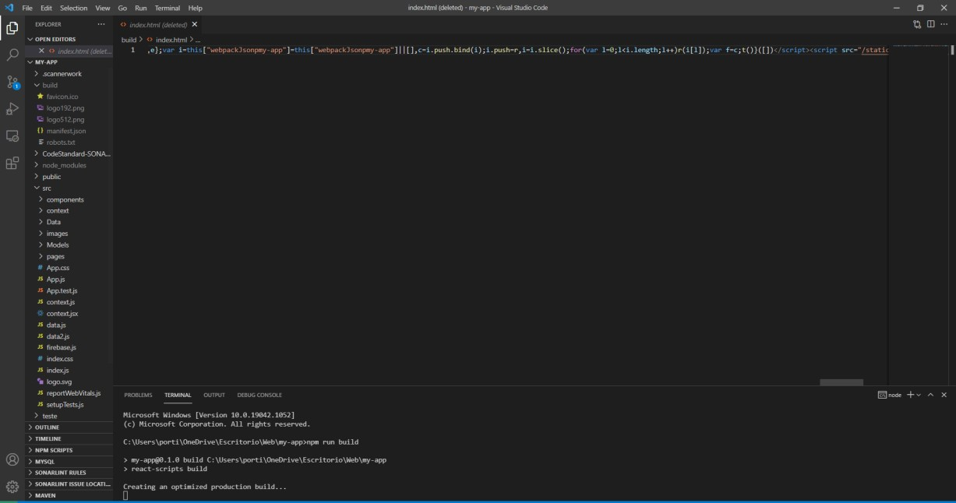

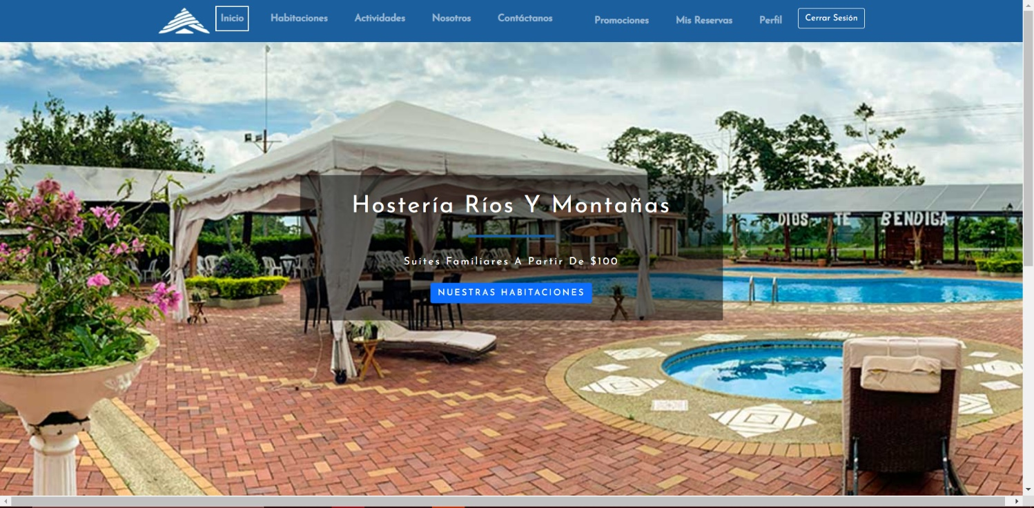

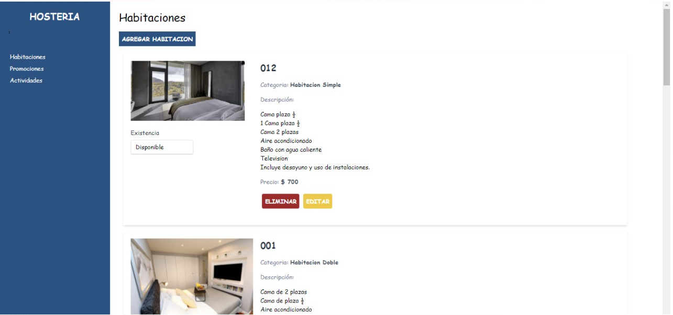

APP MOBILE VERSION:

1. 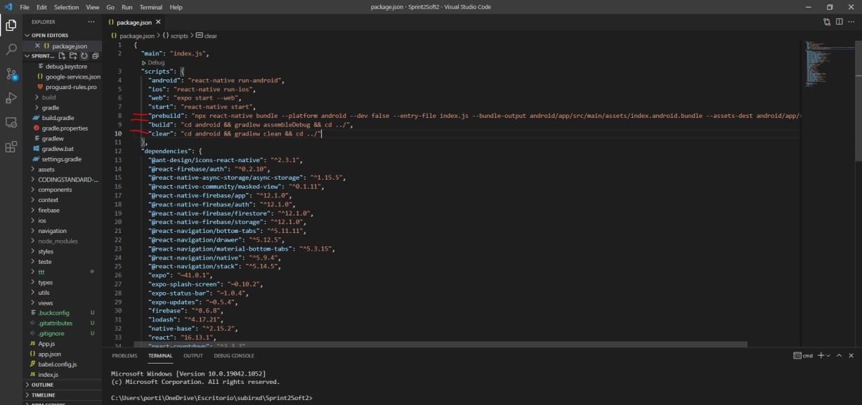Configure this in your package.json file

output android/app/src/main/assets/index.android.bundle --assets-dest android/app/src/main/res", "build": "cd android && gradlew assembleDebug && cd ../",

"clear": "cd android && gradlew clean && cd ../"

"prebuild": "npx react-native bundle --platform android --dev false --entry-file index.js --bundle-

1. run this command “npm run clear”
2. 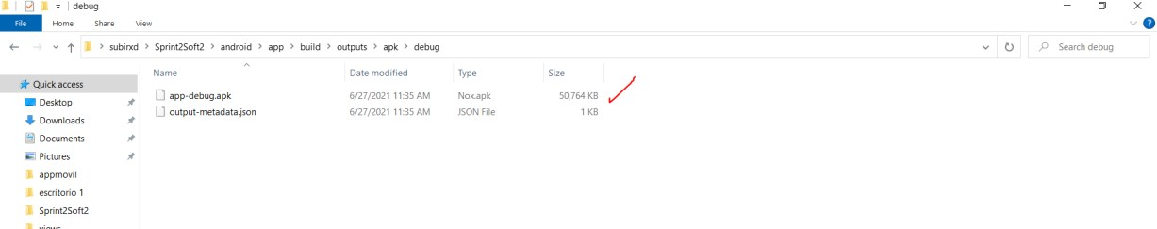Create a empty folder called “assets” in /android/app/src/main folder of your project.
3. run this command “npm run build”
4. Wait for the build, and then we get the APK
5. Run the APK in your android device.

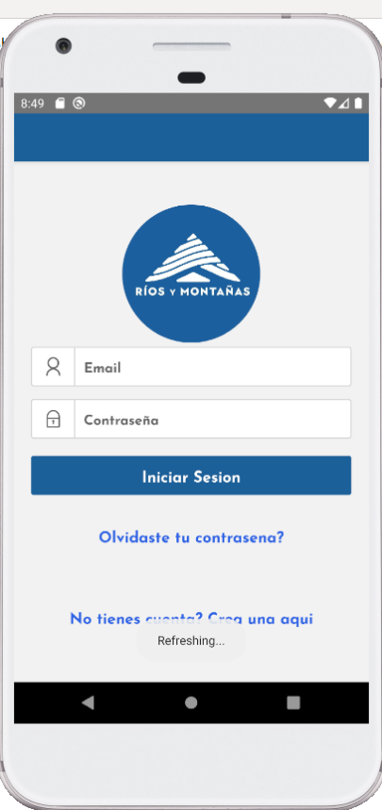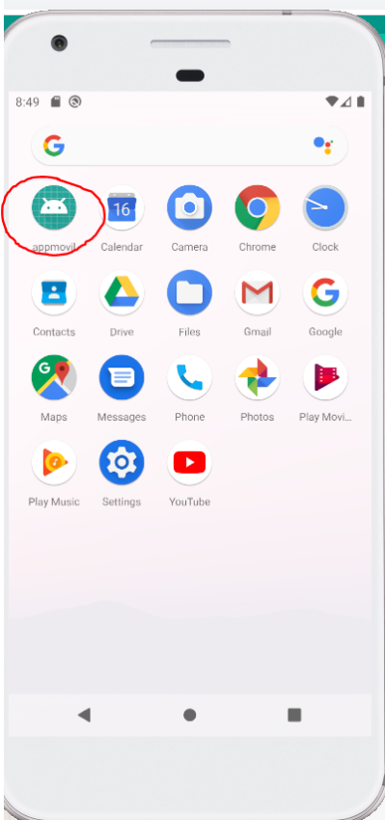

# Evidence of adherence to SCRUM:

**EVIDENCE OF THE CLICK UP**

**Roles**

|  |  |  |
| --- | --- | --- |
| **ASIST** | **ENTES** |  |
| **NOMBRES** |  | **CARGO** |
| Victor Alvarado |  | Jefe de Proyecto |
| Christian Portilla |  | Líder de Proyecto |
| Scarlet Epinoza |  | Scrum Master |
| Albin Arias |  | Desarrollador |
| Leonardo Castro |  | Product Owner |
| Génesis Riera |  | Desarrollador |

**Planning**

* The sprint review with the product owner: 28/06/21 to 14/08/21
* In the sprint 3 and 4, we are going to make: 3 tasks beside the app web and app movil.
* The date scrum meeting: Thursday at 8:30 pm (the product owner also is going to be).

Members of sprint planning 3-4

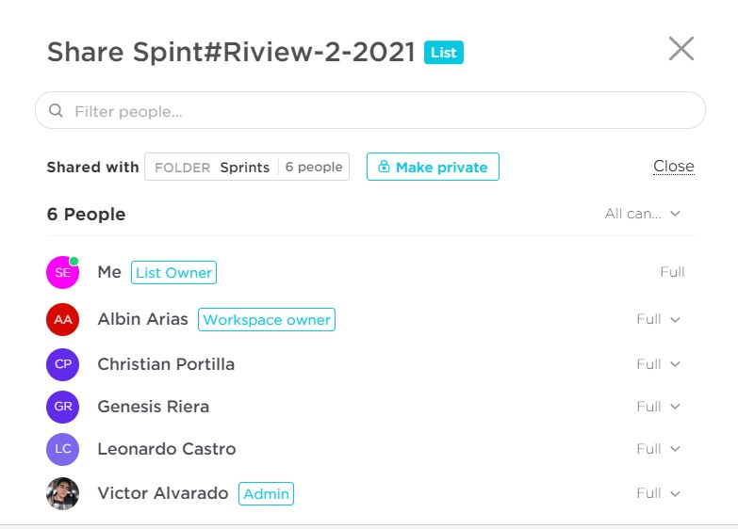

**TASK#10:**Make corrections in the mobile app

* Start date: 9/07/21 to 15/07/21

o Víctor Alvarado, Albín Arias, Christian Portilla, Génesis Riera, Scarlet Espinoza made it.

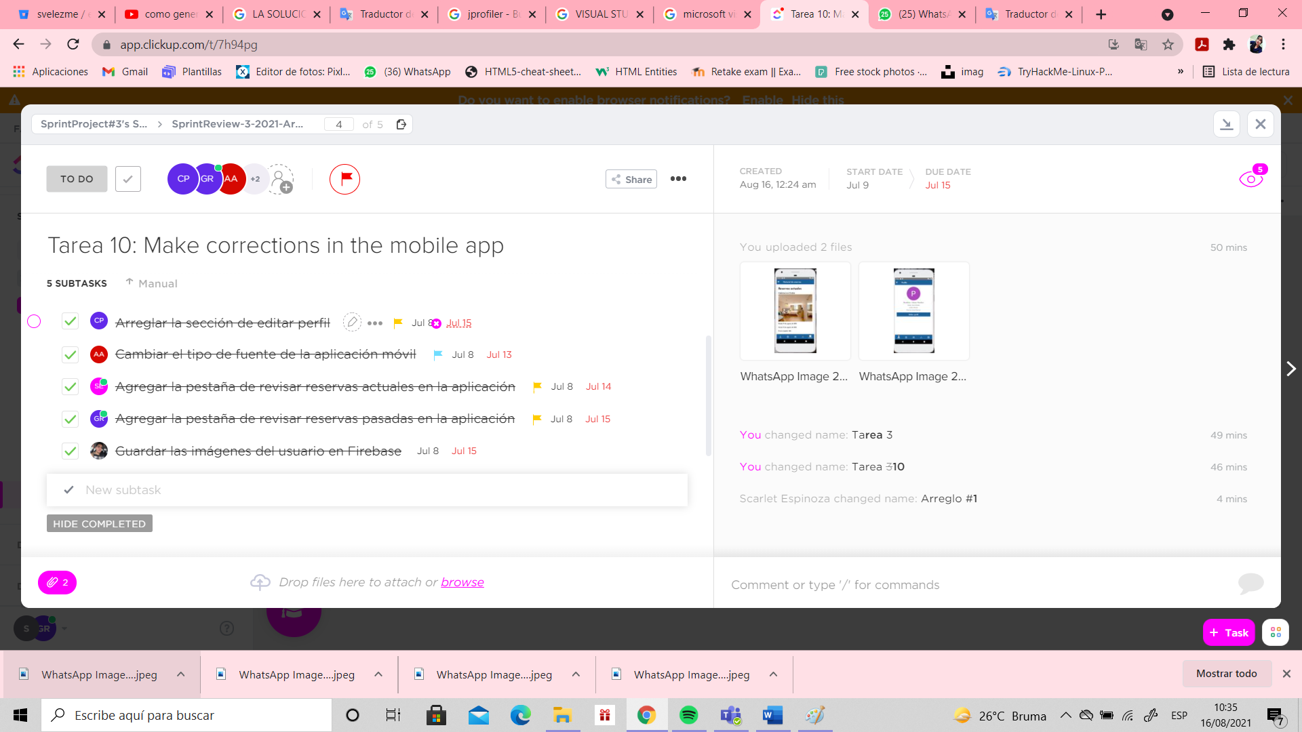**PRODUCT BACKLOG:**

SUBTAKS#10

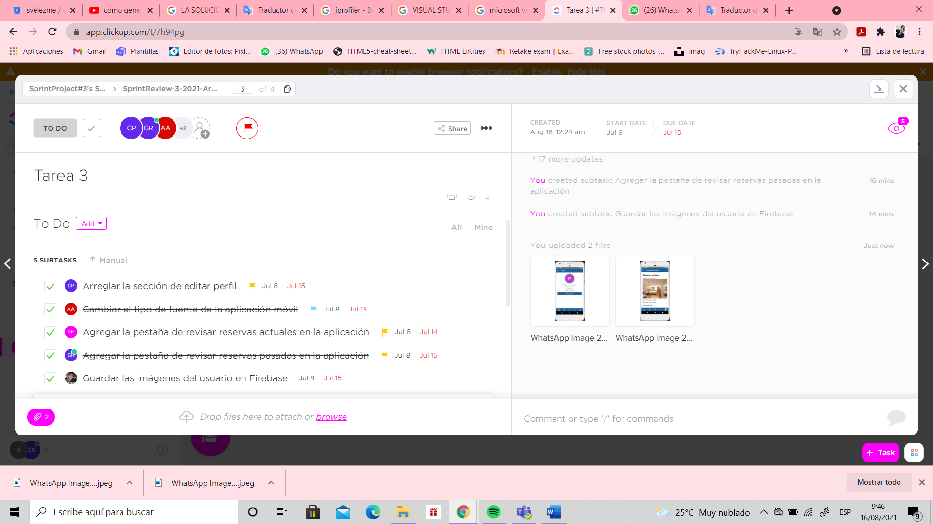

ATTACHMENTS

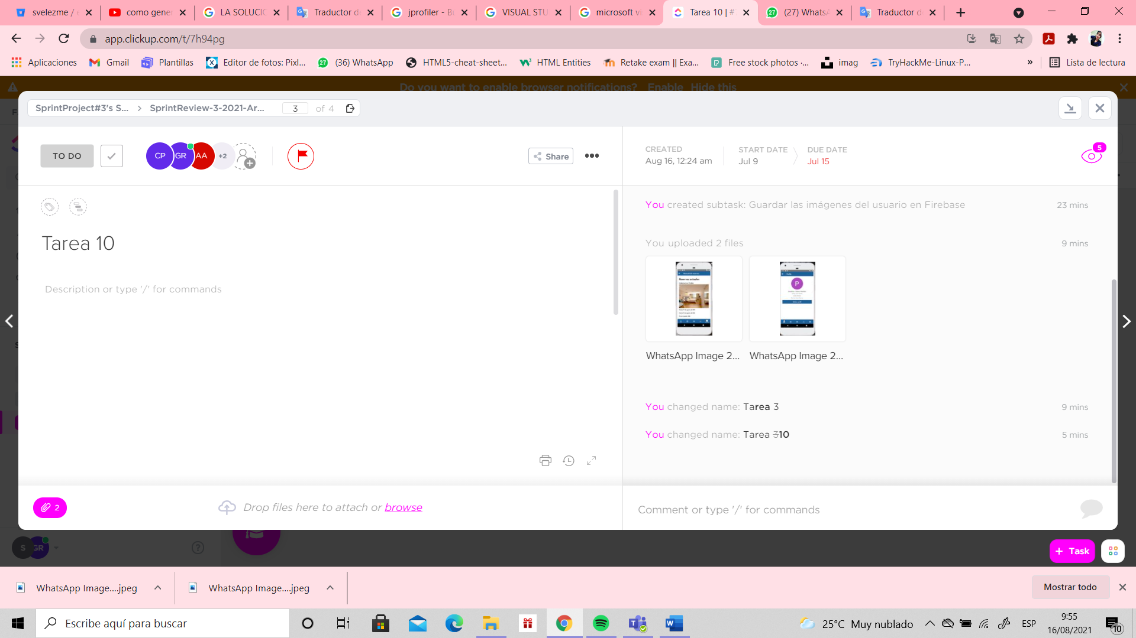

**TASK#11:**Make corrections in the web app

* Start date: 29/06/21 to 16/07/21
* Victor Alvarado, Scarlet Espinoza made it.

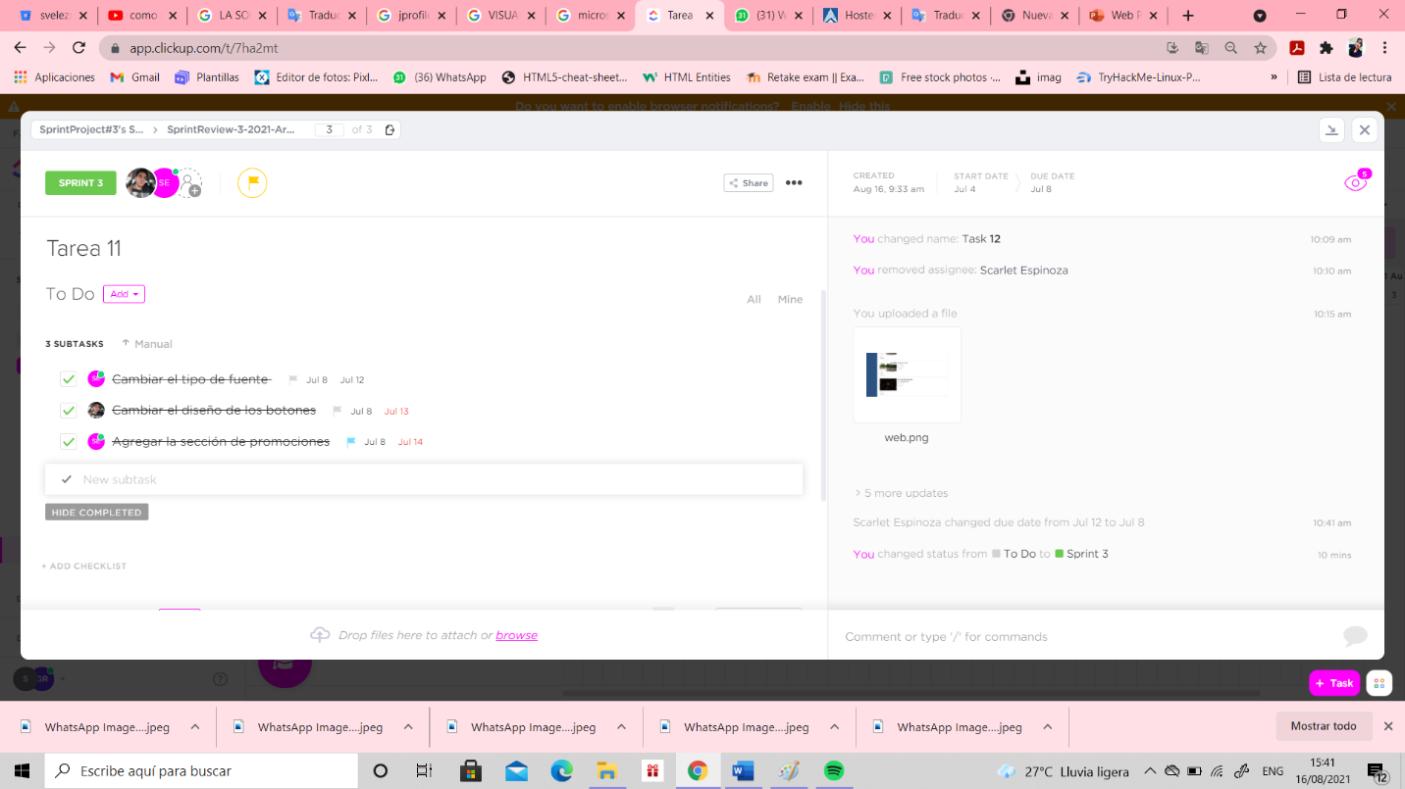**PRODUCT BACKLOG**

SUBTAKS#11

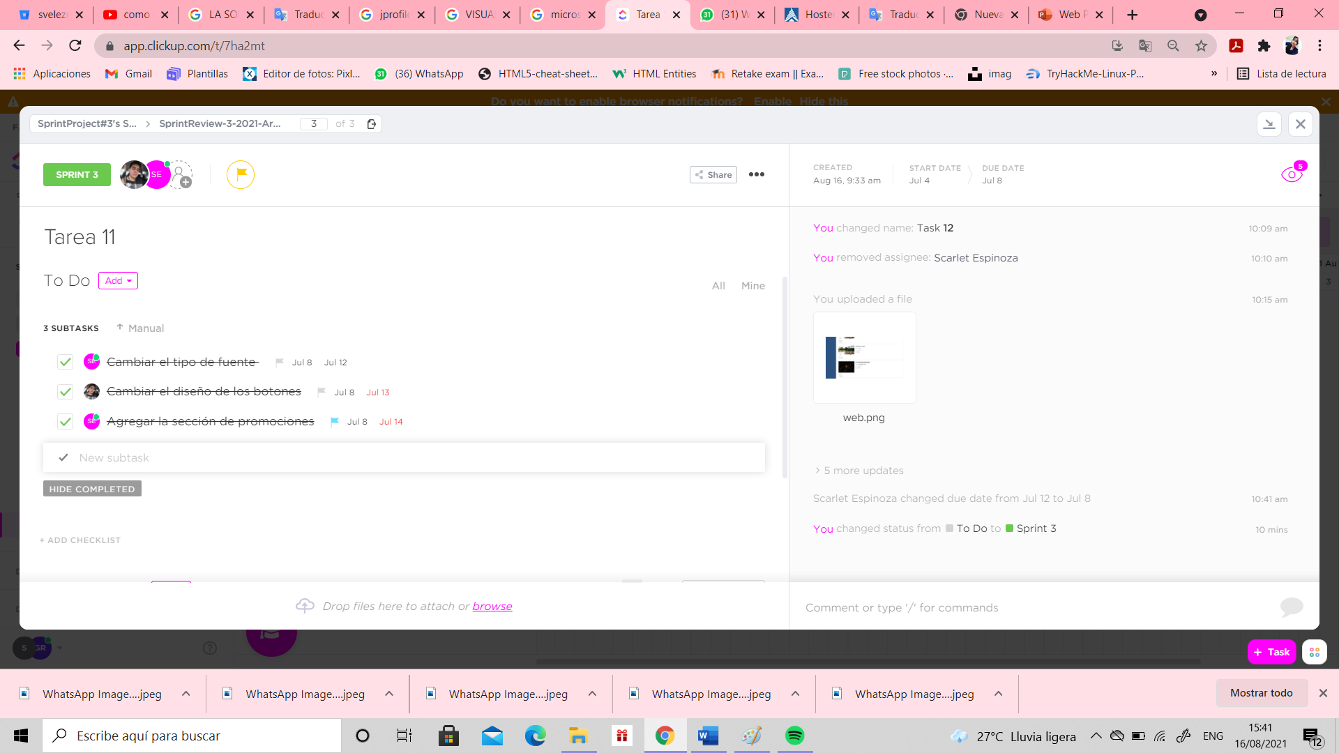

ATTACHMENTS

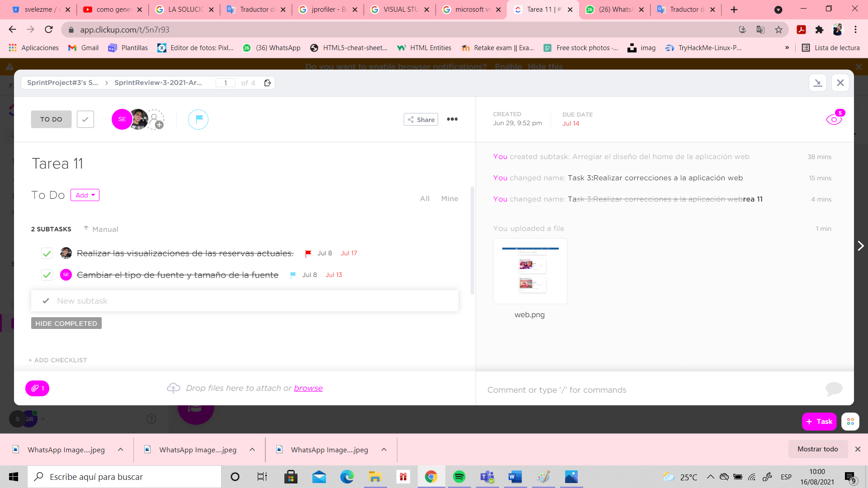

**TASK#12:**Make corrections in the admin panel

* Start date: 9/07/21 to 16/07/21

o Albín Arias, Christian Portilla, Génesis Riera made it.

**PRODUCT BACKLOG:**

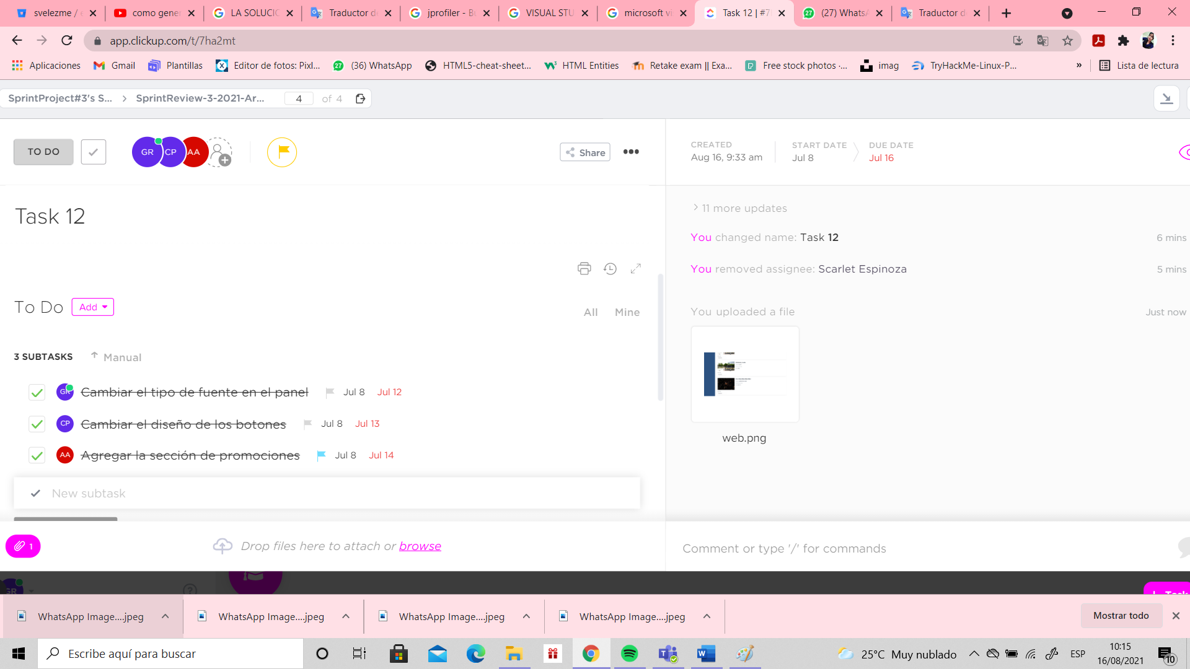

SUBTAKS#12



ATTACHMENTS



**TASK#13:** As a user I want to view the activities offered by the application.

* Start date: 9/07/21 to 15/07/21

o Albín Arias, Christian Portilla made it.

**PRODUCT BACKLOG:**

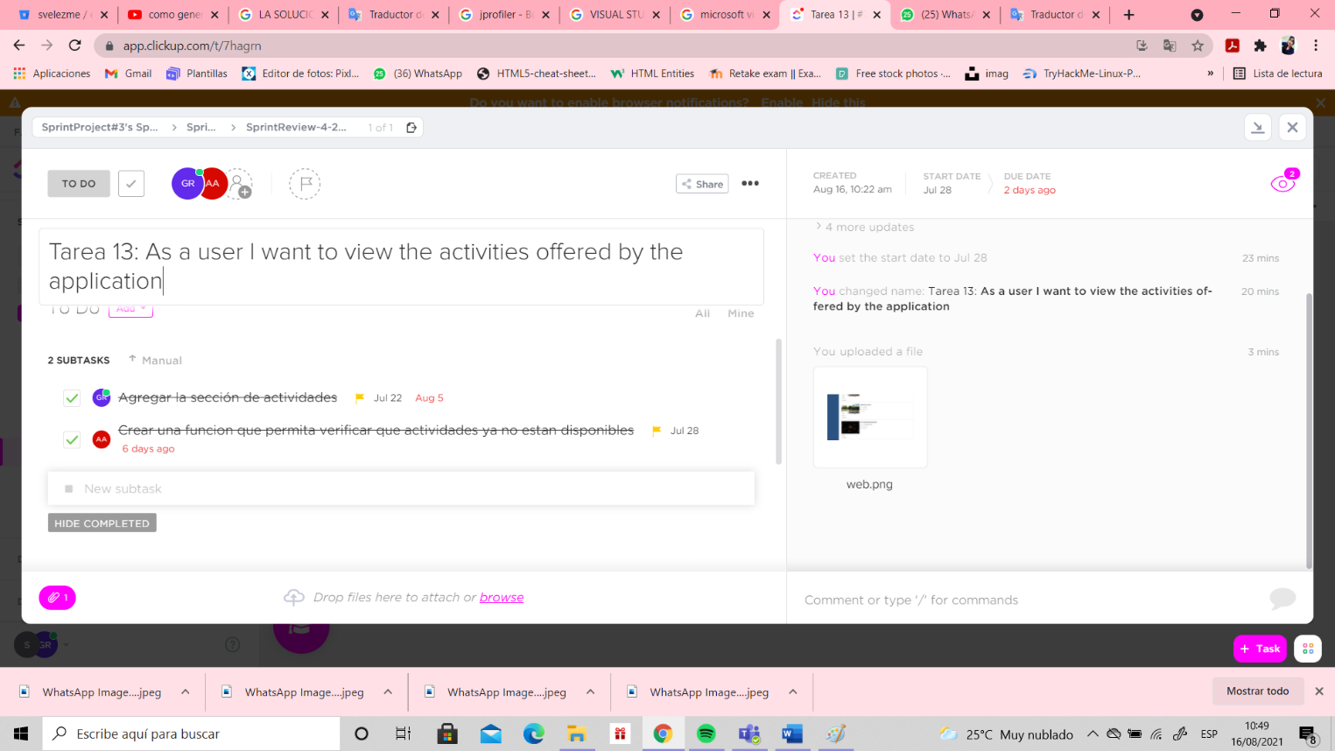

SUBTAKS#13

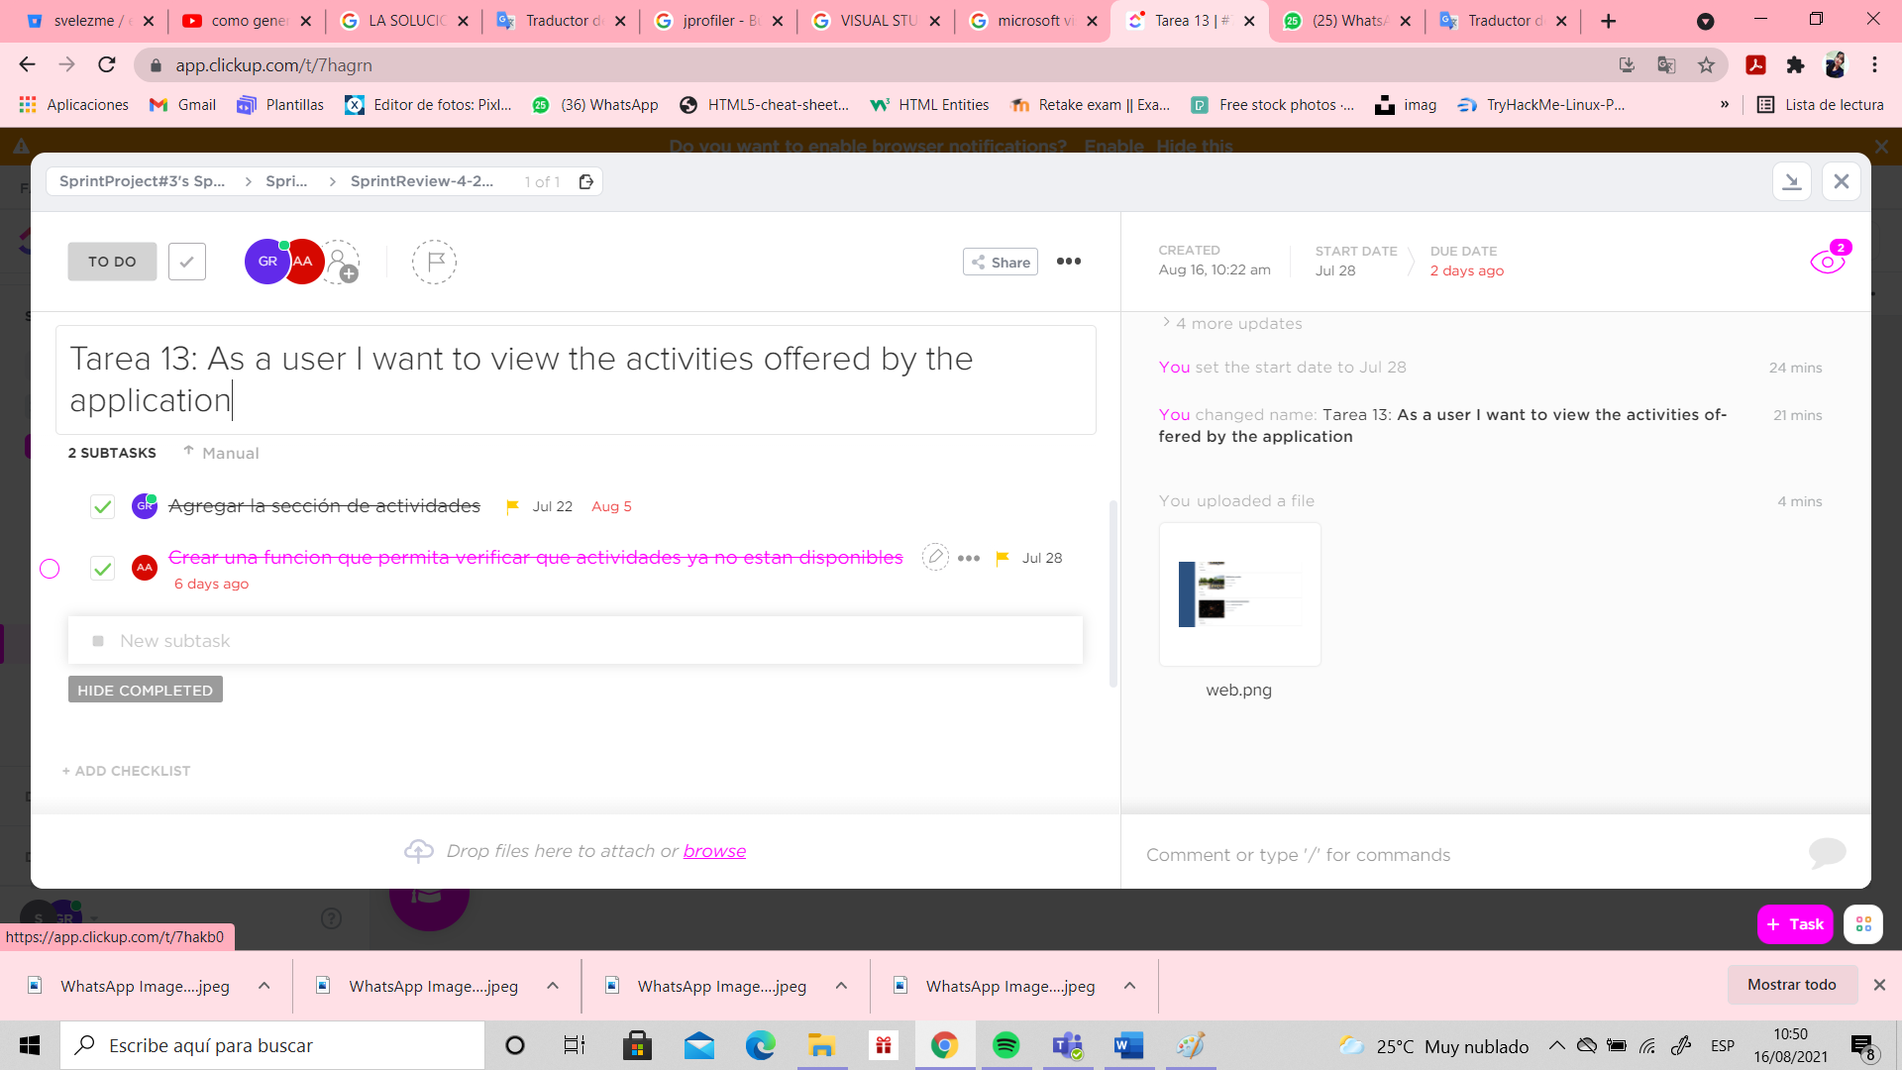

ATTACHMENTS

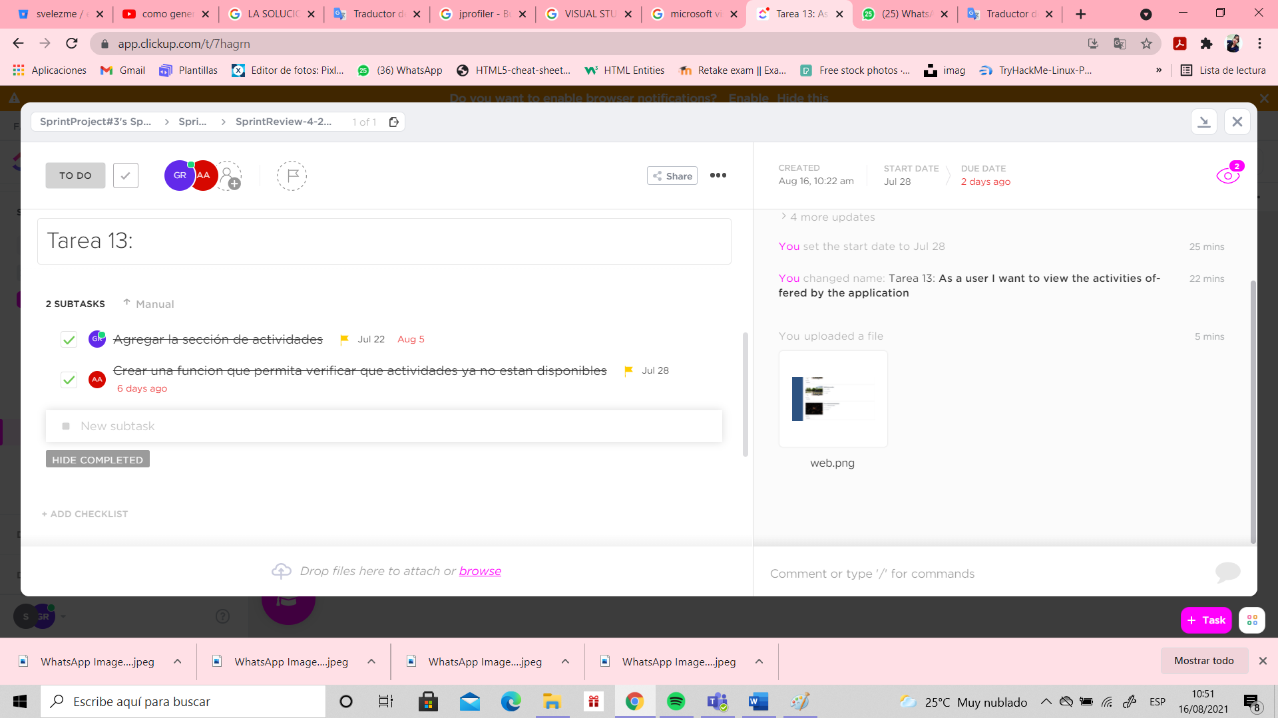

**TASK#14:**As a user I want to verify the payment methods that are available in the web application

* Start date: 28/07/21 to 11/08/21

o Scarlet Espinoza, Victor Alvarado made it.

**PRODUCT BACKLOG:**

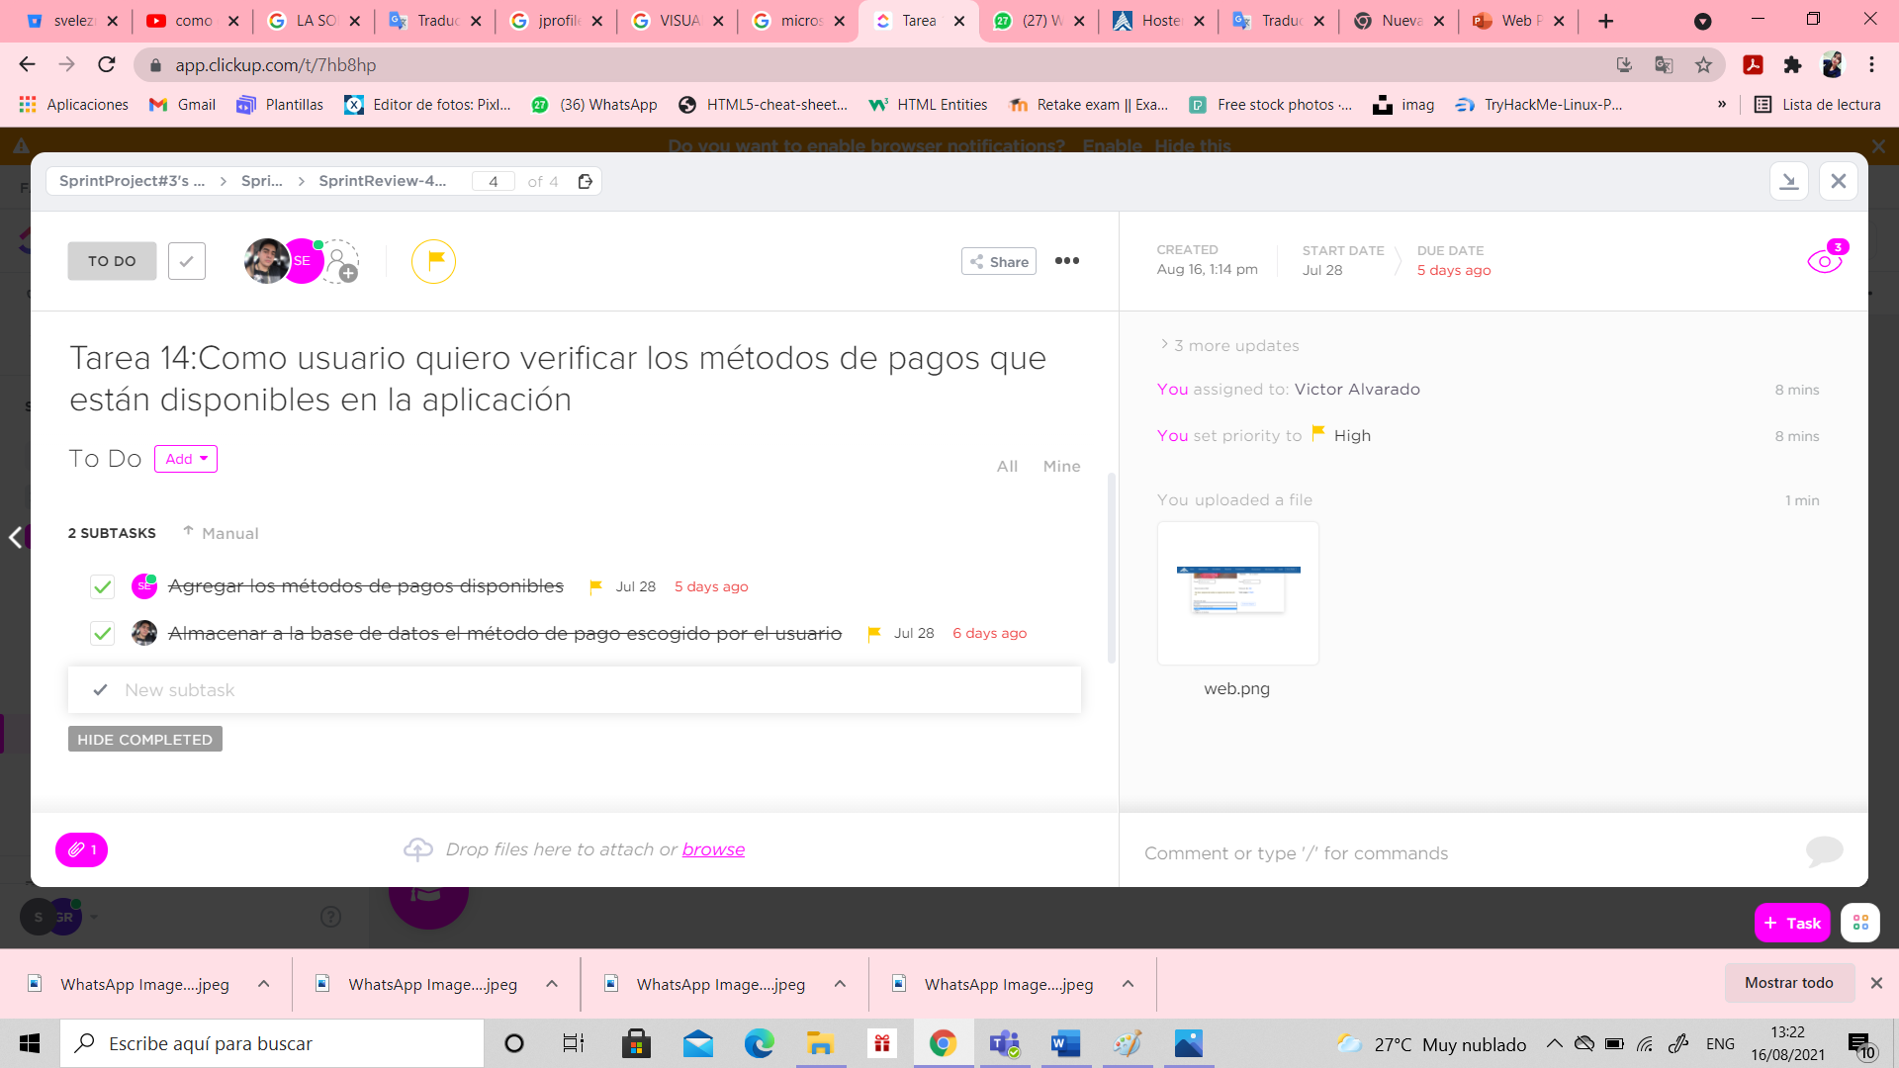

SUBTAKS#14



ATTACHMENTS



**TASK#15:** As a user I want to verify the payment methods that are available in the mobil application

* Start date: 28/07/21 to 12/08/21

o Christian Portilla, Génesis Riera and Albín Arias made it.

**PRODUCT BACKLOG:**

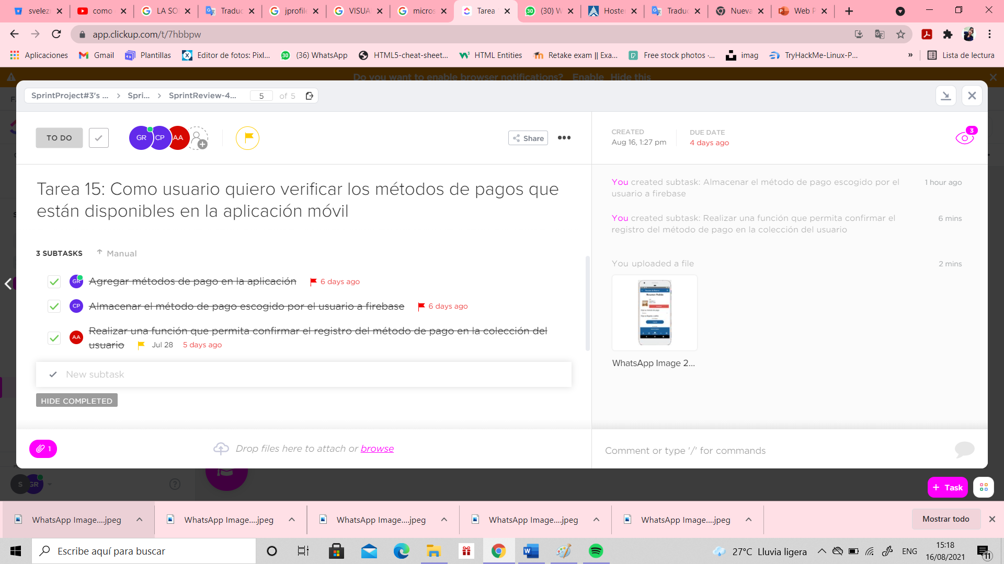

SUBTAKS#15



ATTACHMENTS



**PRODUCT BACKLOG FINISHED, TASK IN GENERAL IN SPRINT 3**

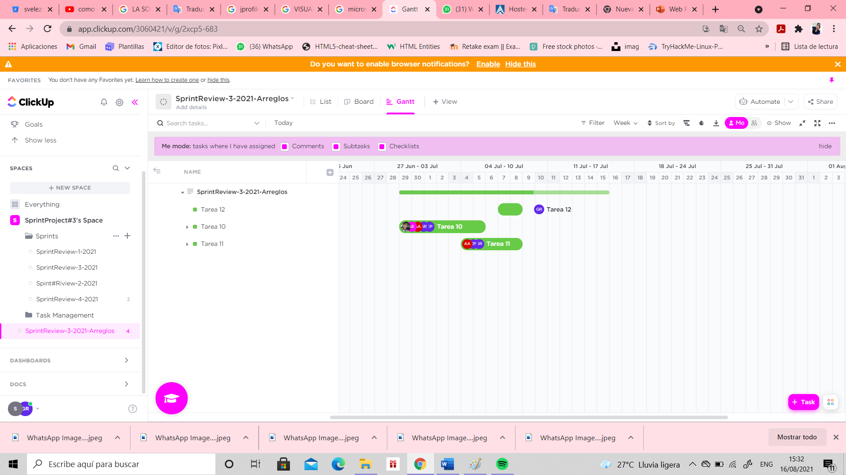

PER SUBTAKS#10

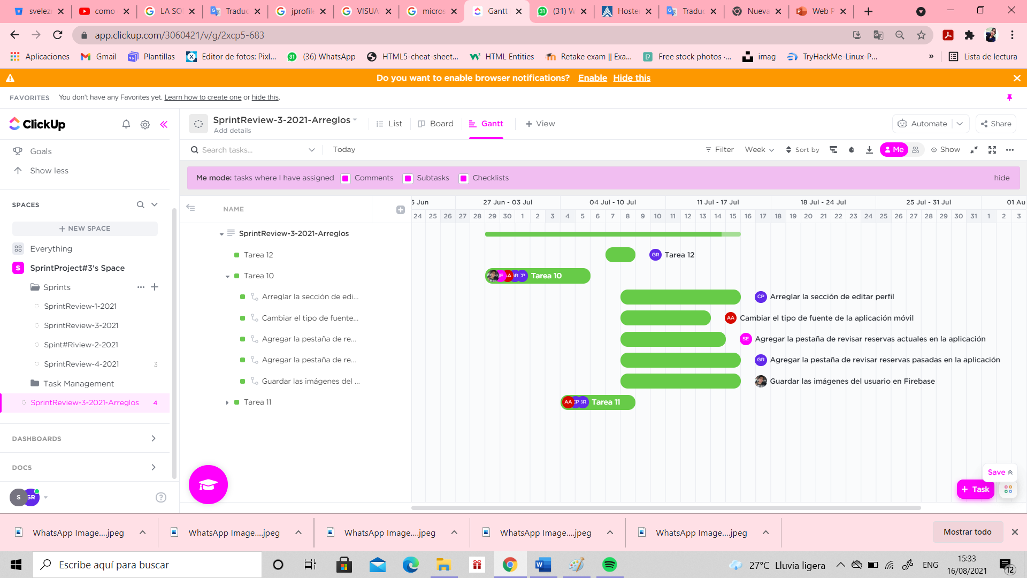

PER SUBTAKS#11

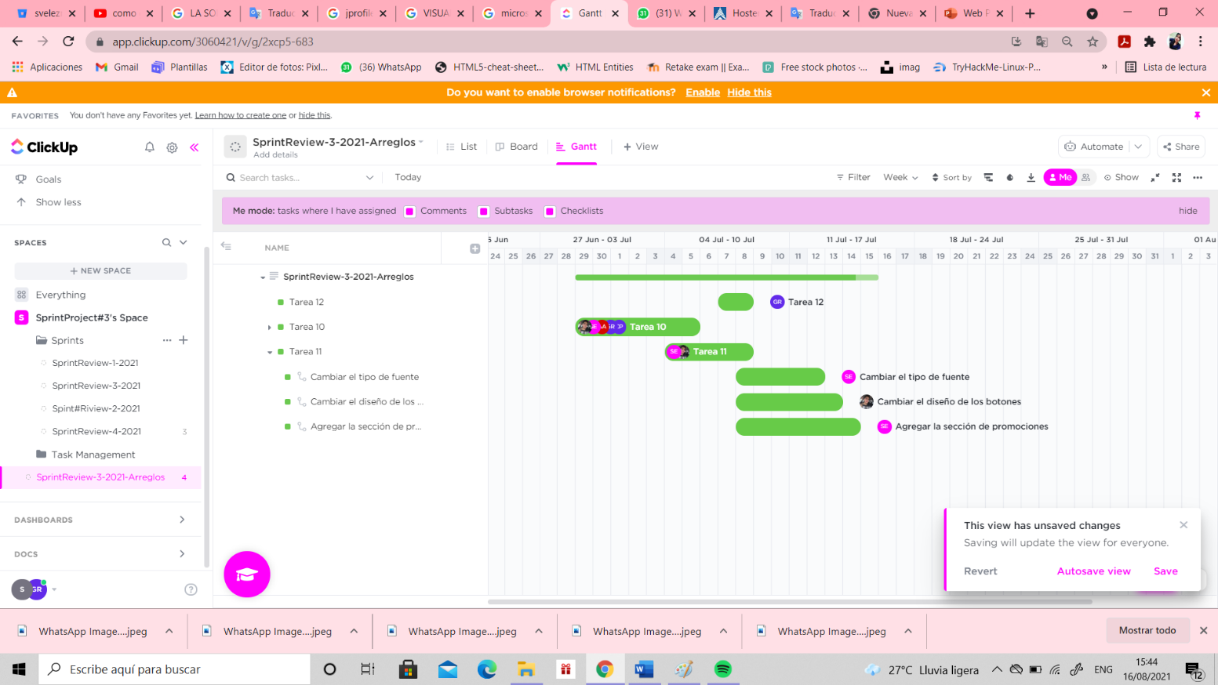

PER SUBTAKS#12

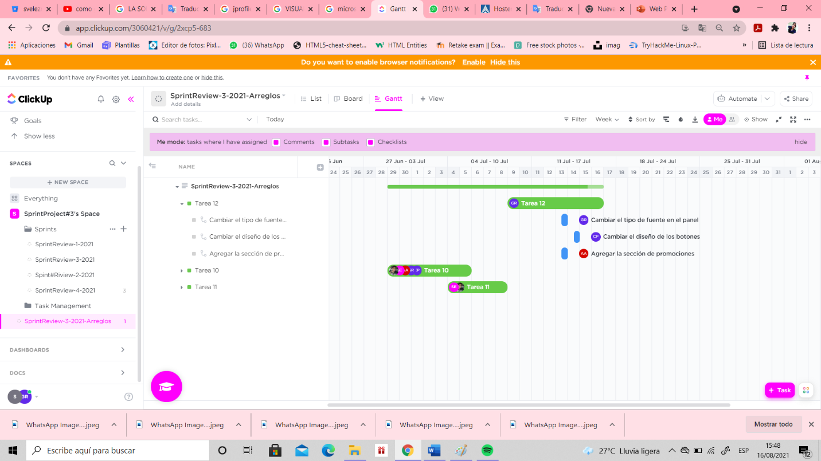

**PRODUCT BACKLOG FINISHED, TASK IN GENERAL IN SPRINT 4**

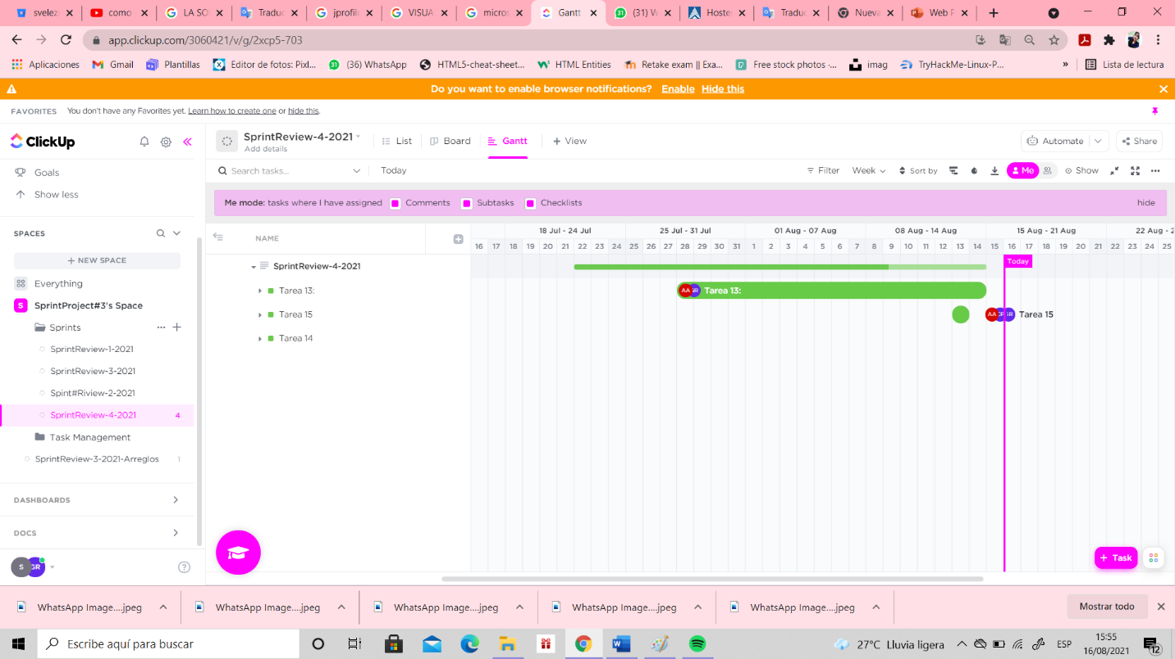

PER SUBTAKS#13

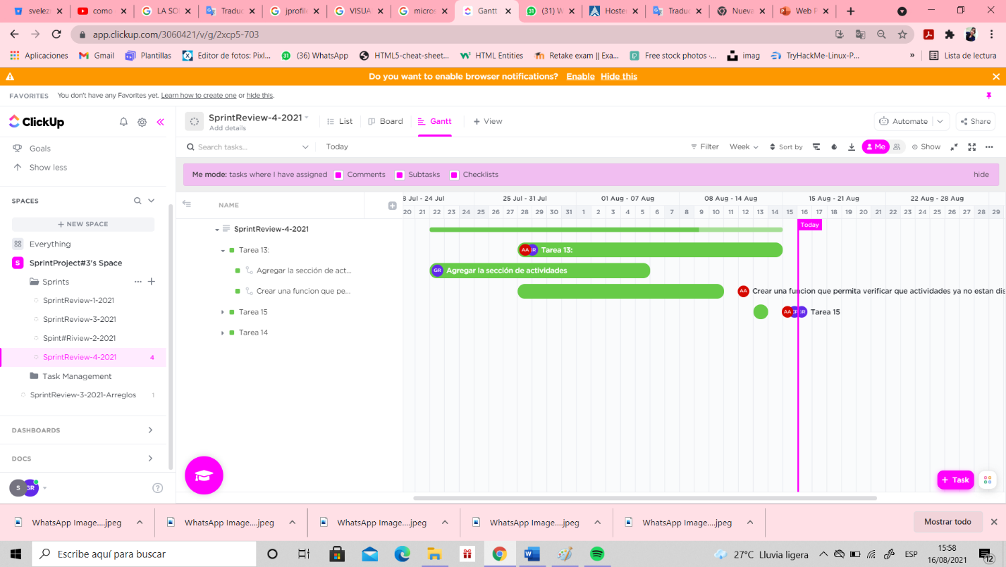

PER SUBTAKS#14

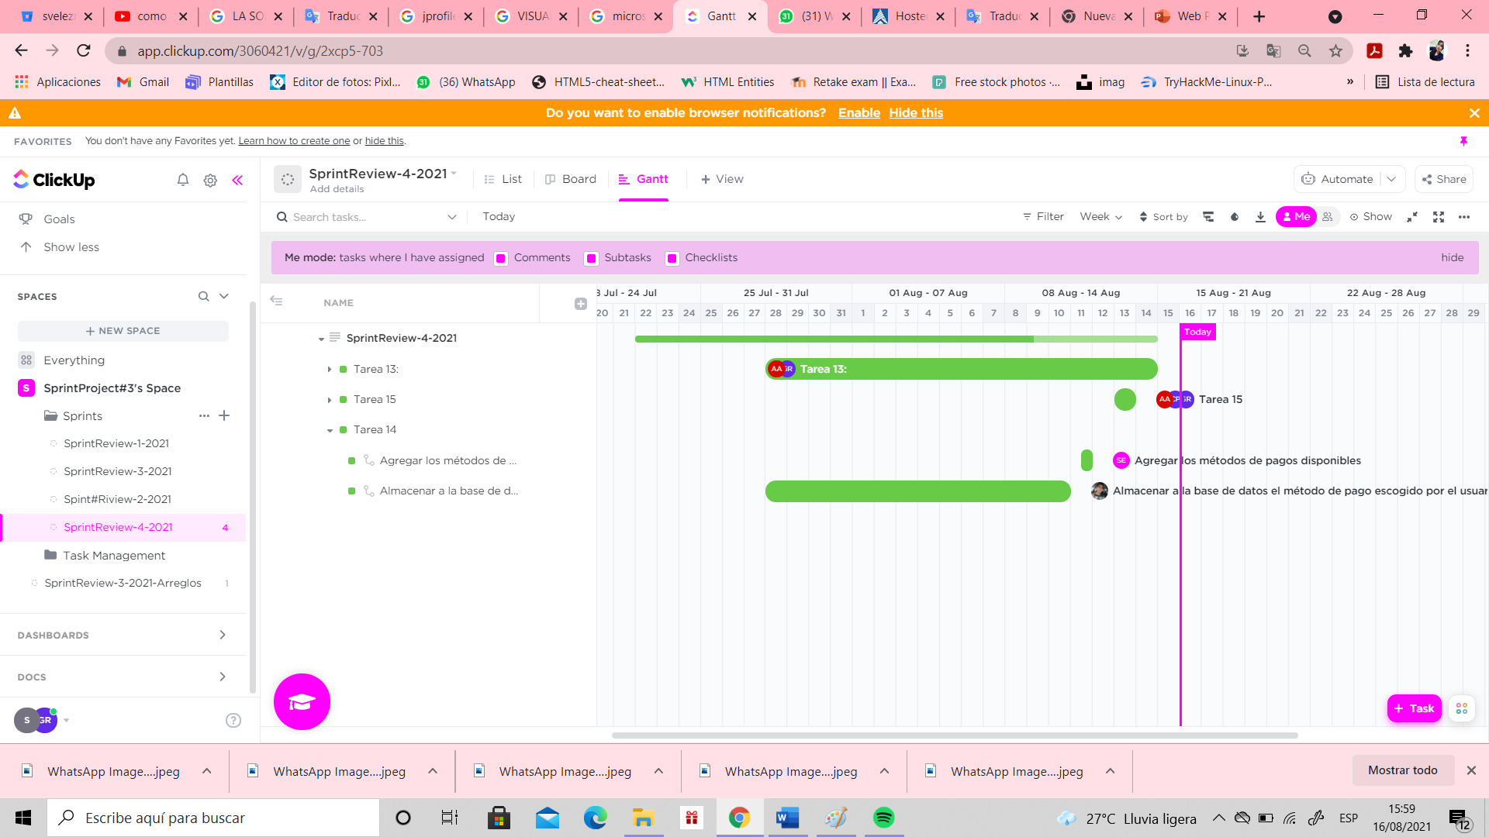

PER SUBTAKS#15

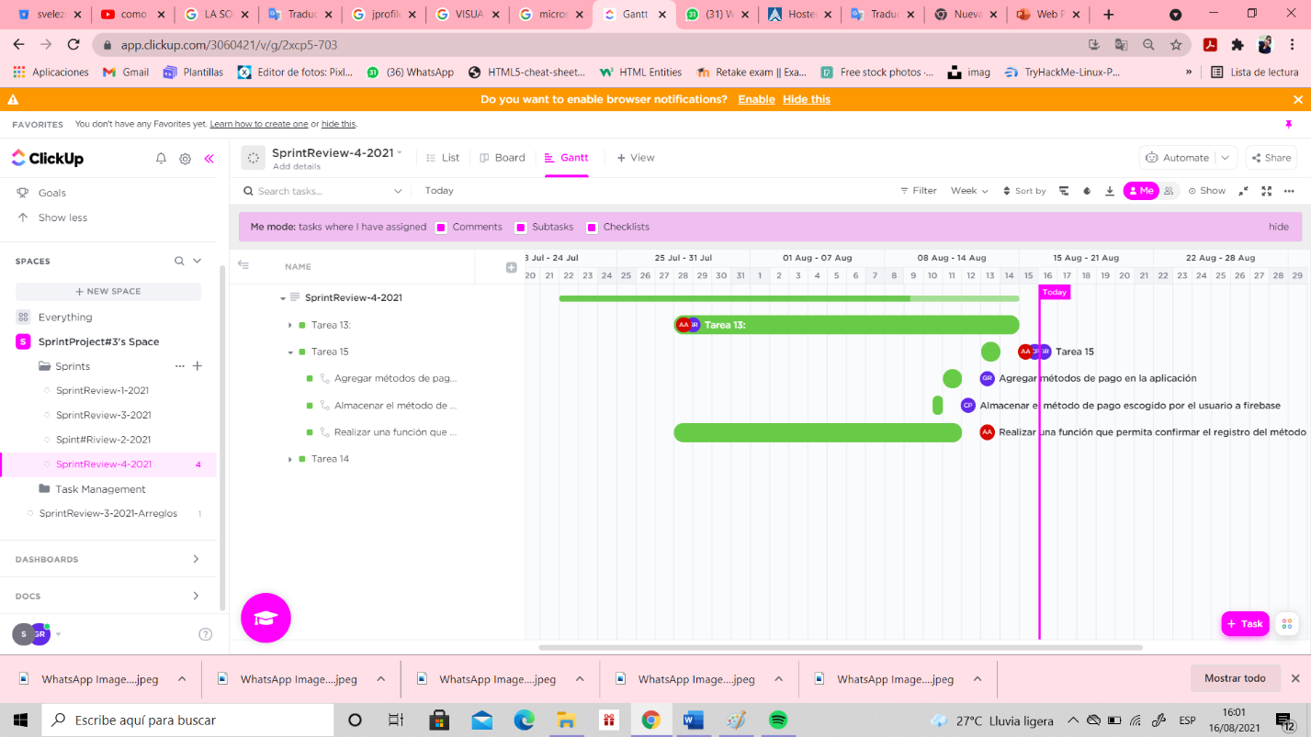

**SPRINT#3-END WITH EVIDENCE**

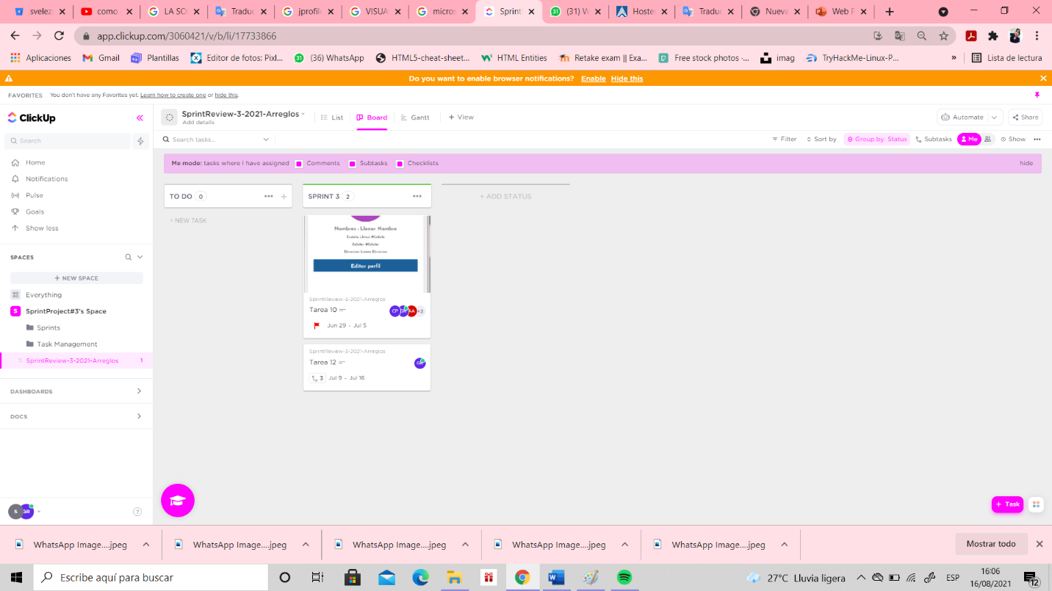

**SPRINT#4-END WITH EVIDENCE**

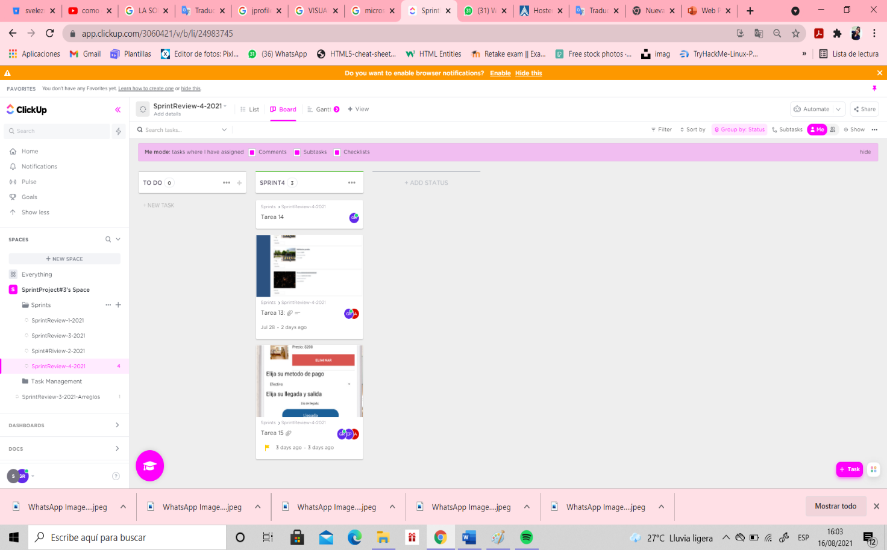

# Coding Standard Documentation Detecting and Enforcing Coding Standards.

The Coding Standard in the project was realized with **SonarQube**, it is is a platform for evaluating source code. It is free software and **uses various static code analysis tools such as Checkstyle, PMD or FindBugs** to obtain metrics that can help improve the quality of a program's code.

**Evidence from the web:**

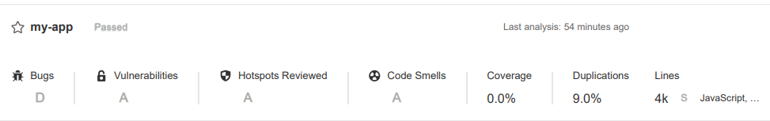**Calcification that sonar gave to our app web:**

**Some Rules applied:**

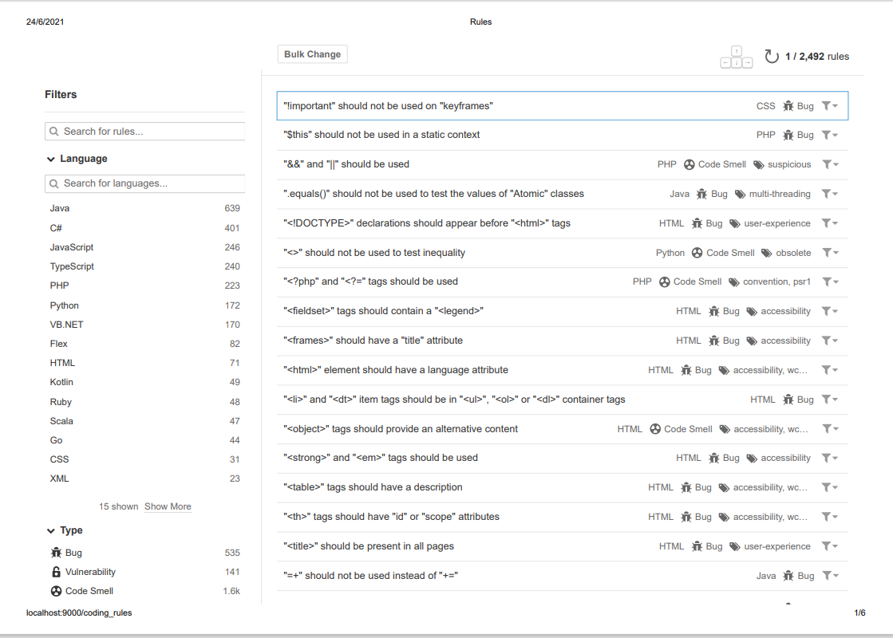

**Bugs:**

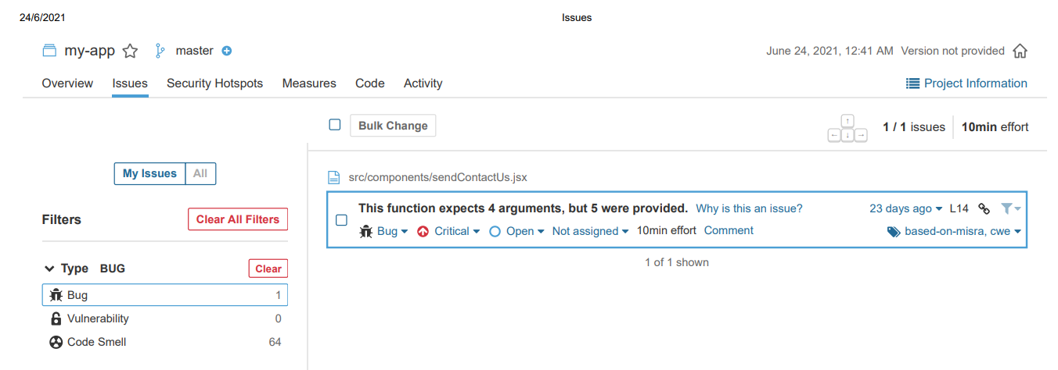

**Grafic:**

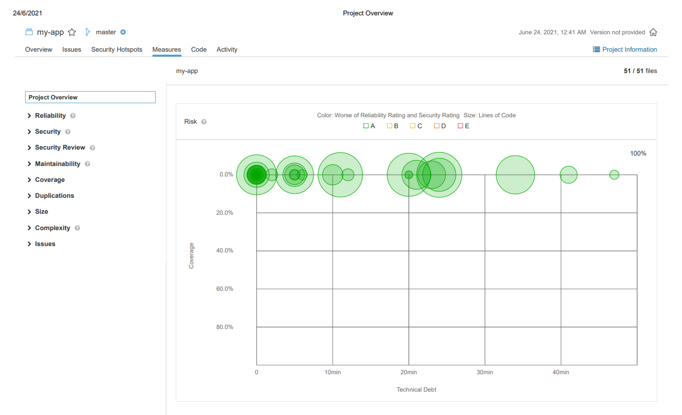

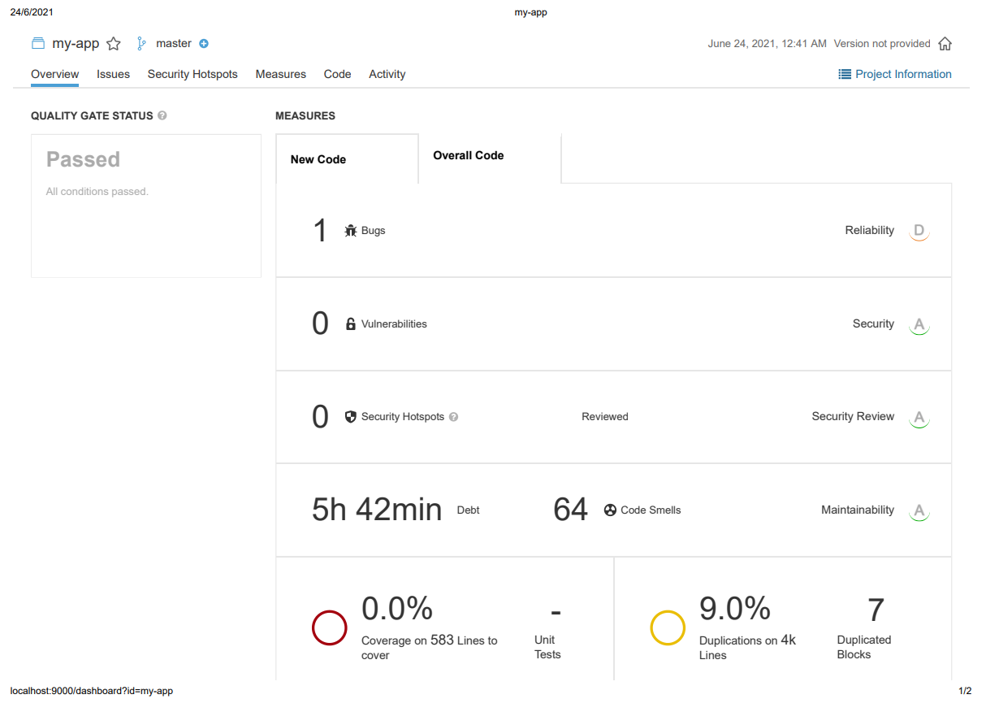**Measures:**

**Evidence from the App Movil:**

**Calcification that sonar gave to our app movil:**

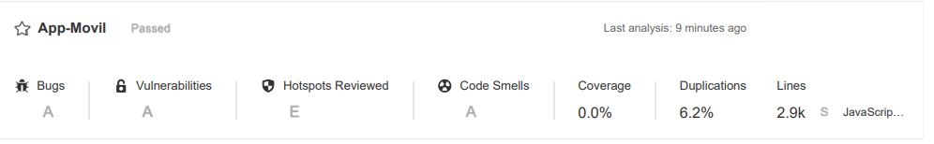

**Some Rules applied:**

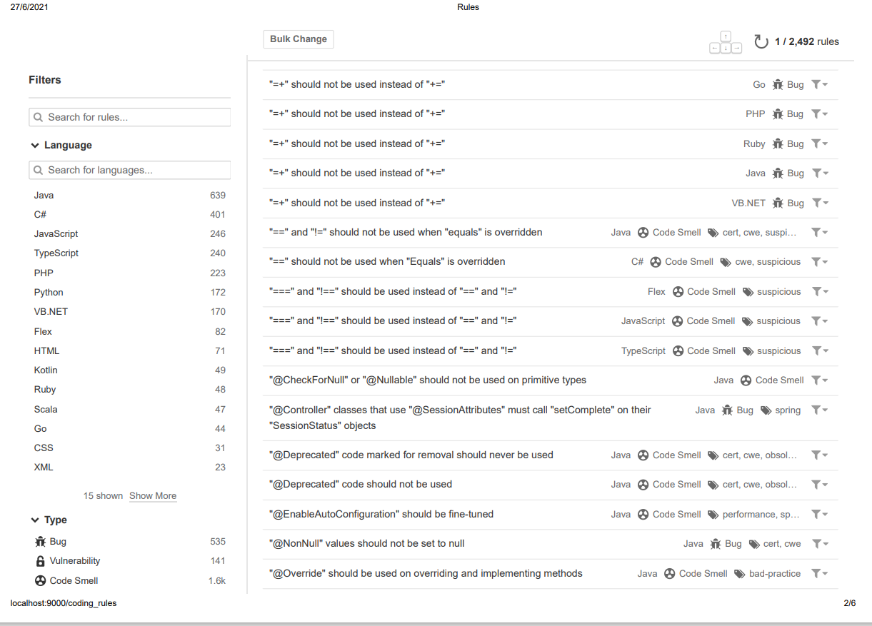

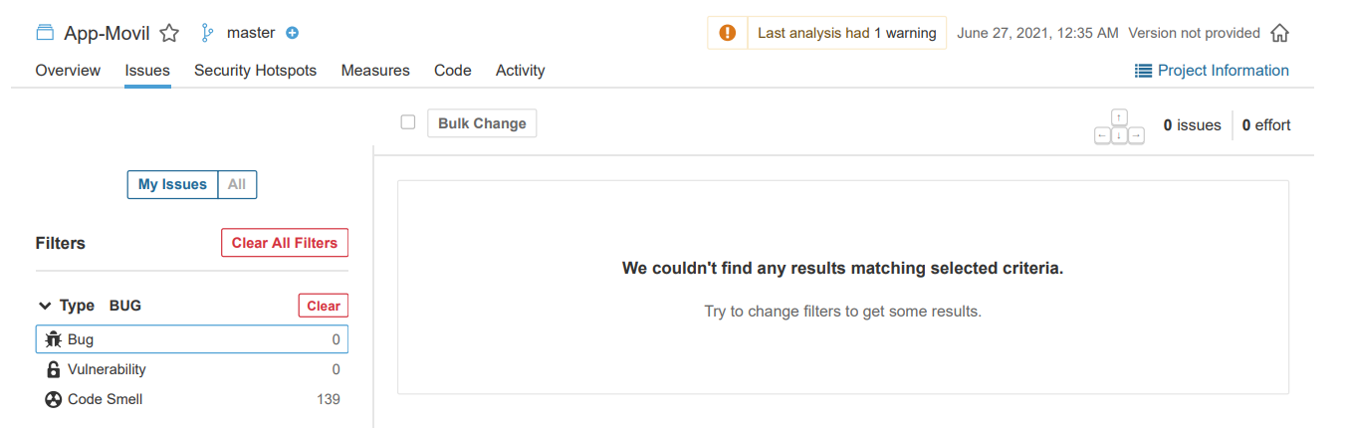**Bugs:**

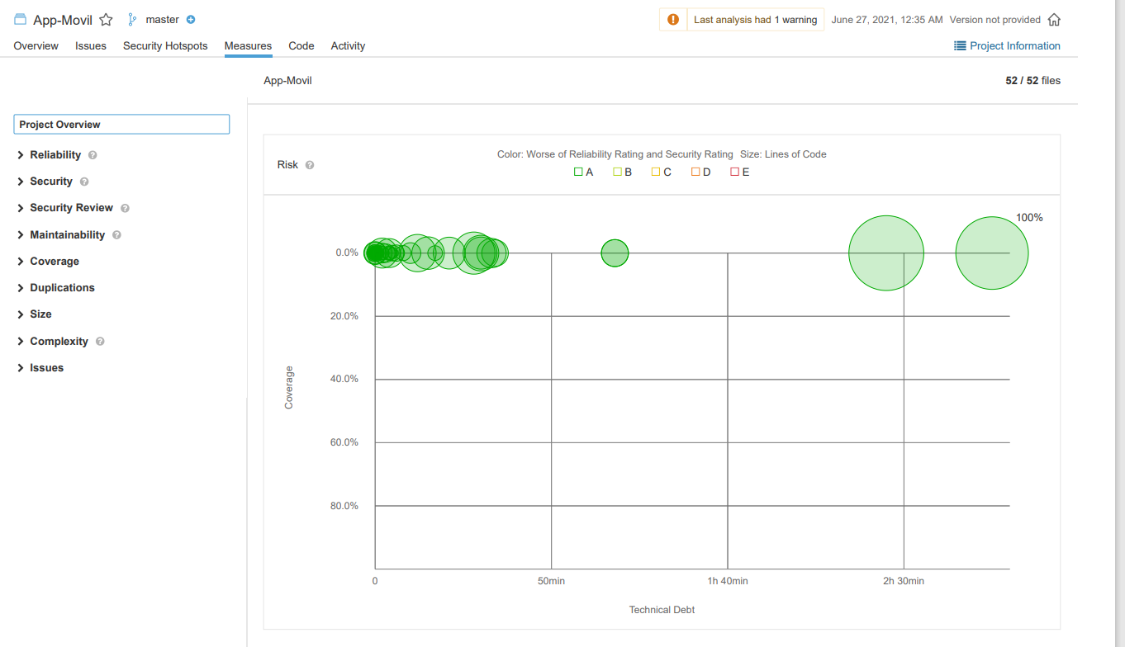**Grafic:**

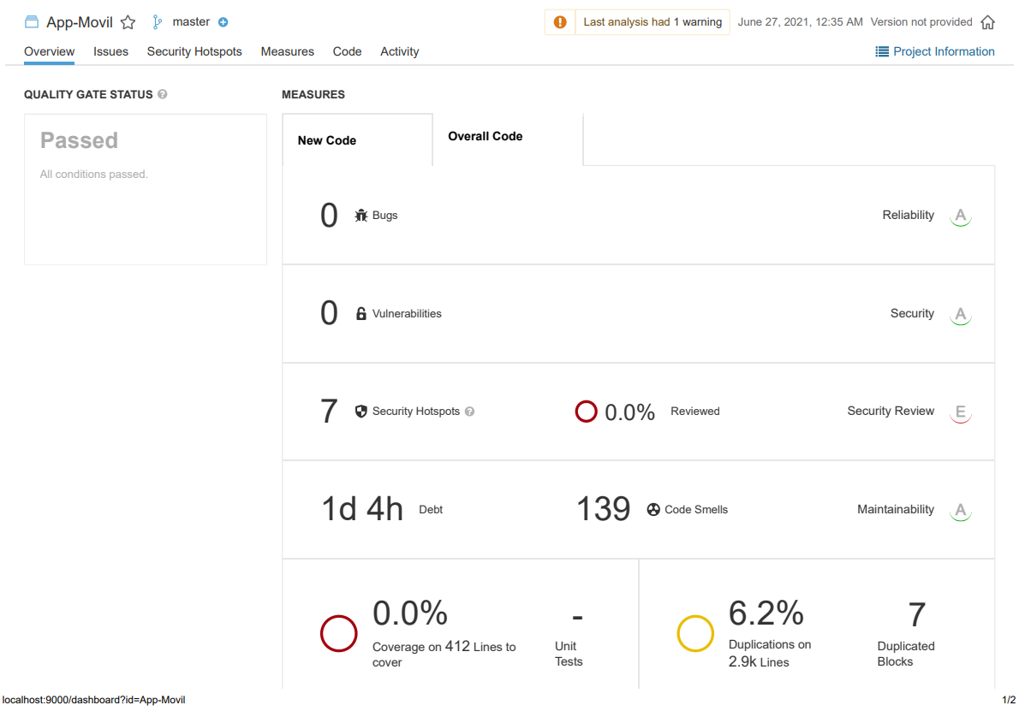

**Measures:**

# Preemptive Error Detection

**PMD** is a static source code analyzer. It finds common programming flaws like unused variables, empty catch blocks, unnecessary object creation, and so forth. It’s mainly concerned with **Java and Apex.**

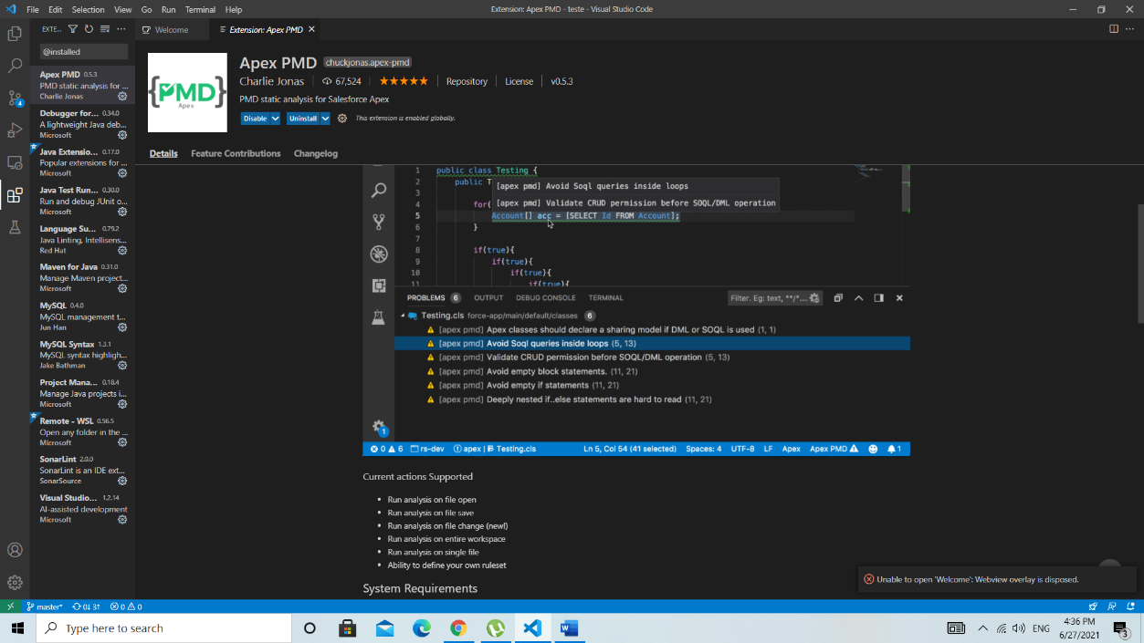**The first step we must do is install "Apex PMD", "Java test runner" and "Maven for Java '**

Then you go to the view section and open the command palette and open the command “ Mave: Create maven project”. We choose the latest version and then we write the name of the folder in which the files will be found with the analysis of the errors of the project.

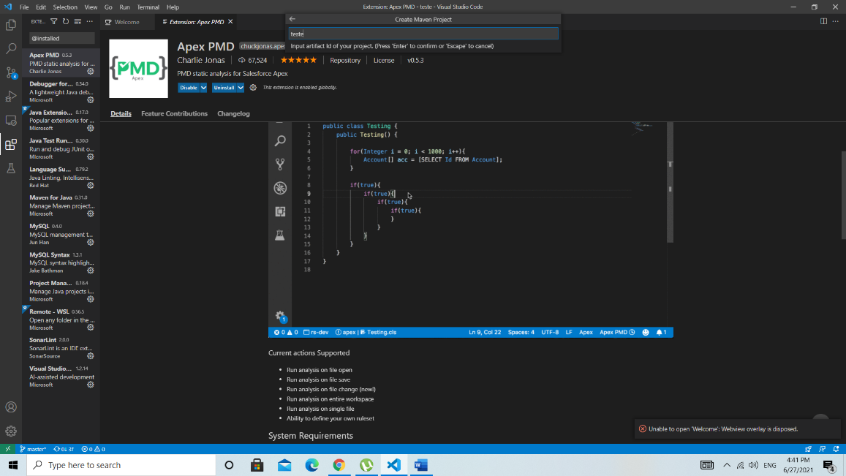

Then we will use the command "Maven: Create Maven Project", from there you select the option that allows you to open a java application, you choose the latest version in this case 2.0.0, well that's how you are creating the tests for the project. the name of the folder in this case I put “Teste” 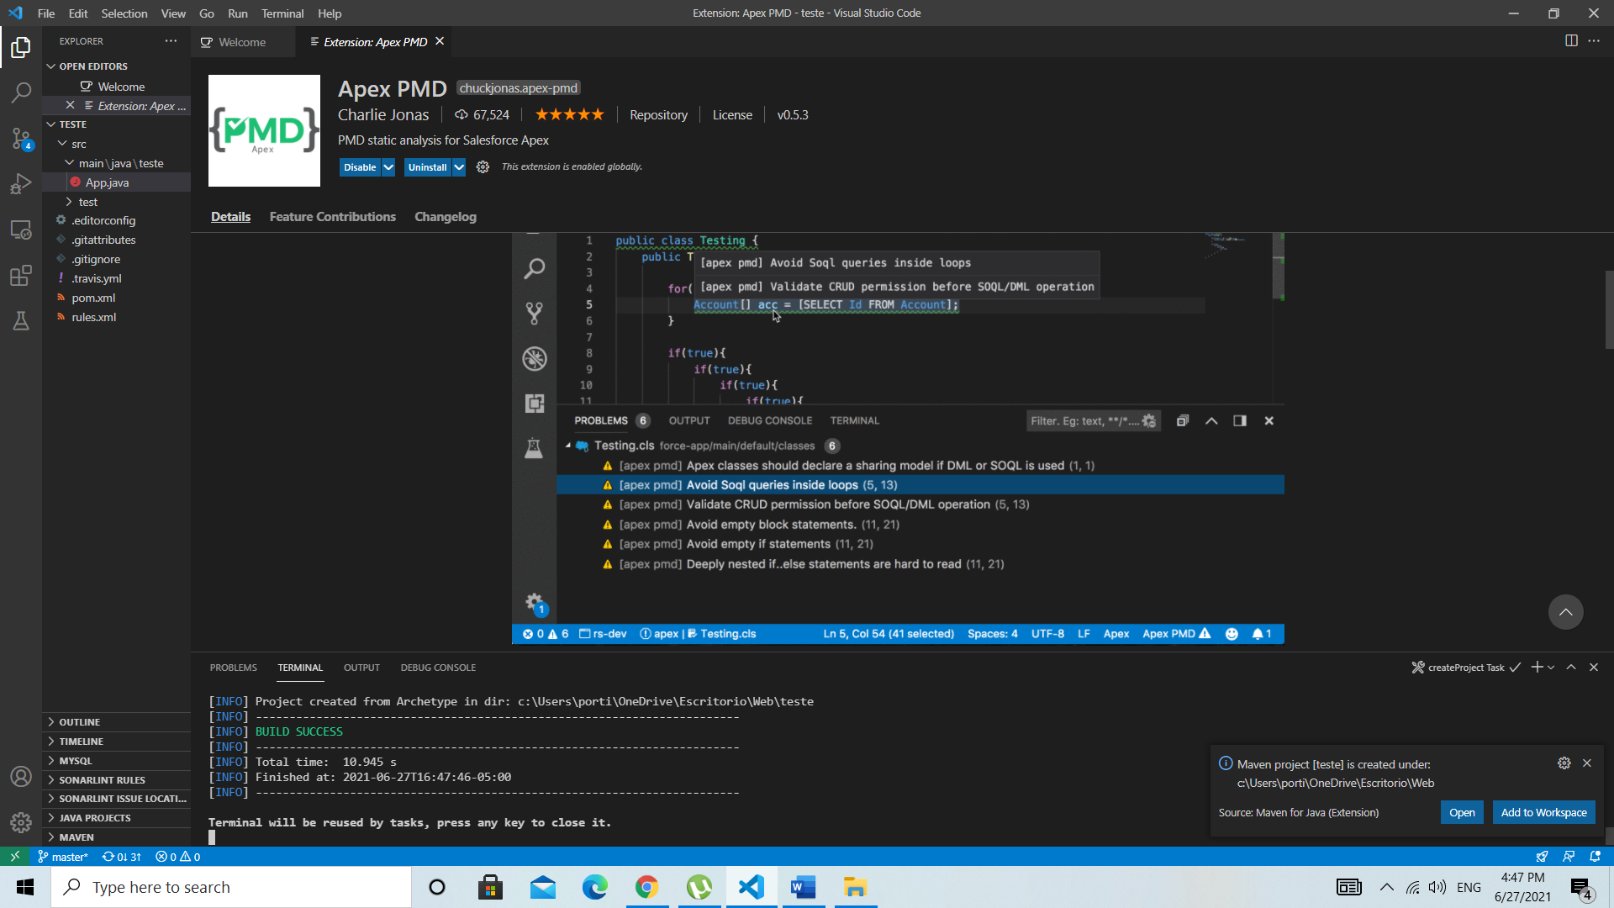

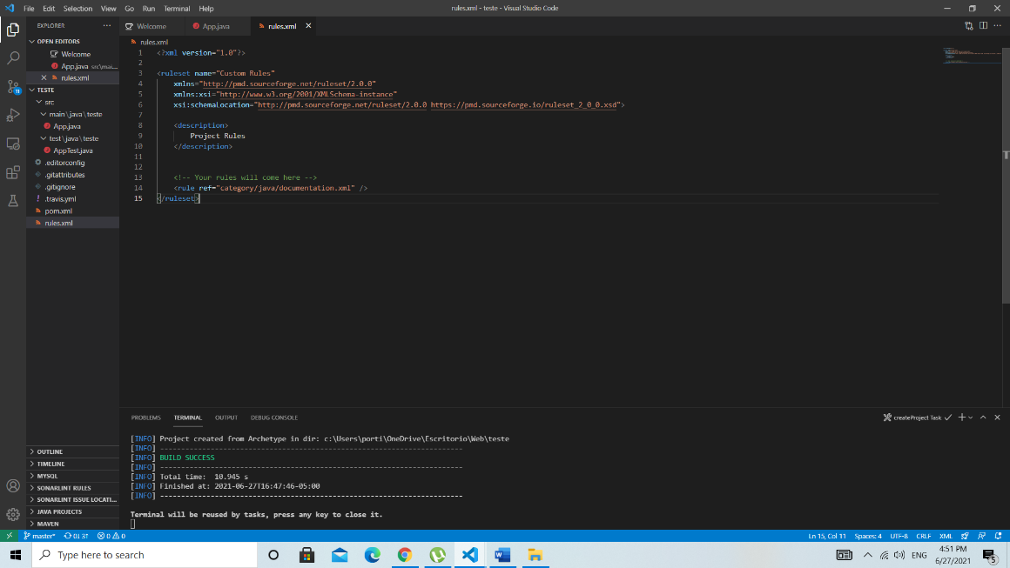And the teste folder of the project is automatically opened in visual studio, ntonces in the test folder some files are automatically created, but we must create the ‘rules.xml” file.<rule ref="category/java/documentation.xml" /> That line of code extracts the Java documentation in which all the error sections that you may have in your project are found so as not to be putting all of them because there are quite a few.

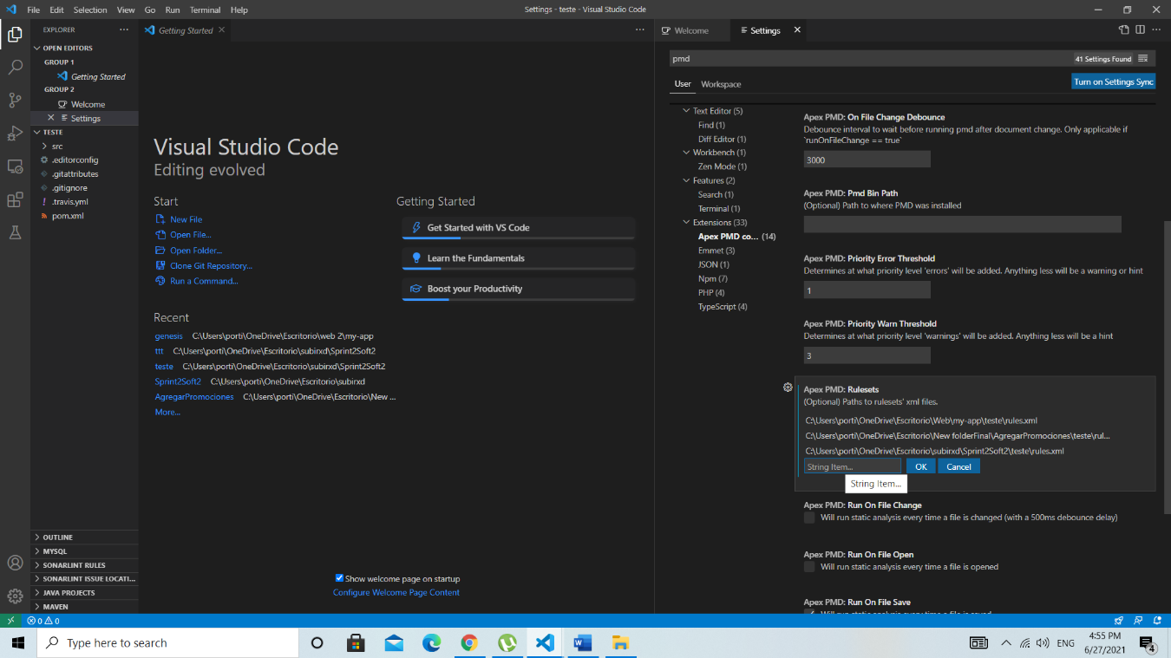Once you have that you go back to the command palette and there you put "ferences: Open user settings. You look for the option" Apex: PMD: Additional Classes Paths, there you are going to add the Apex path of the roules.xml file.

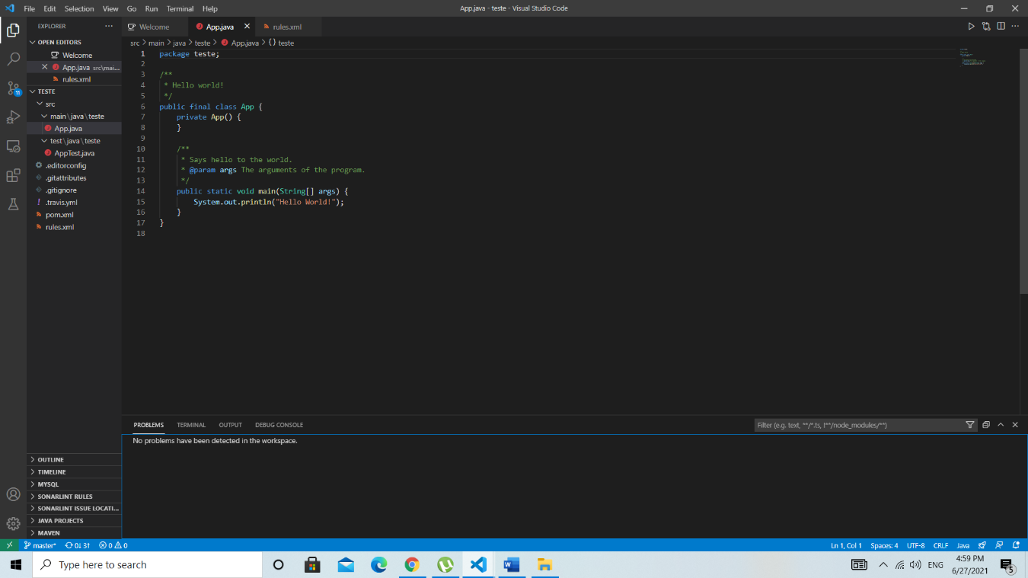Once you add it, you go to the App.java test document and put the Apex Static Alalysis option on workspace, and there you have the errors.

We can see that the "test" folder was created in the project.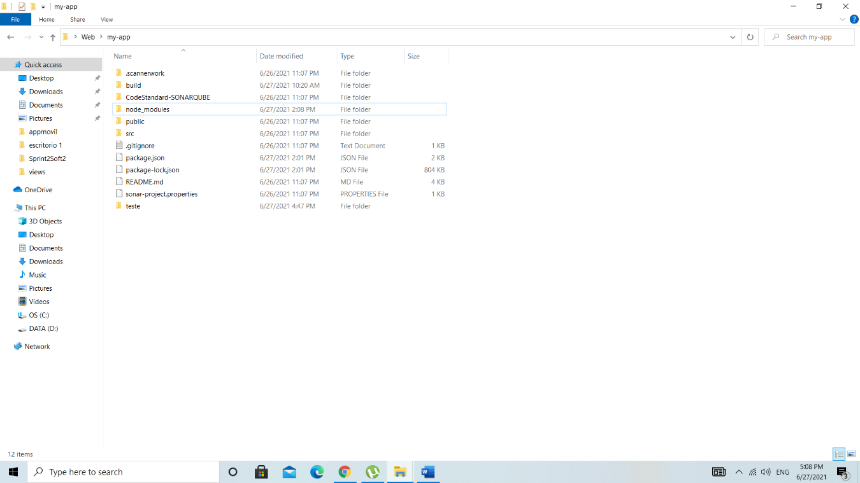

# Use of a continuous integration tool (e.g. Jenkins) with quality data.

# Use of a tool to perform acceptance testing.

# Application profiling

**Panel Admin**

For the profiler of our development in react we use a Google Chrome extension called "React Developer Tools".

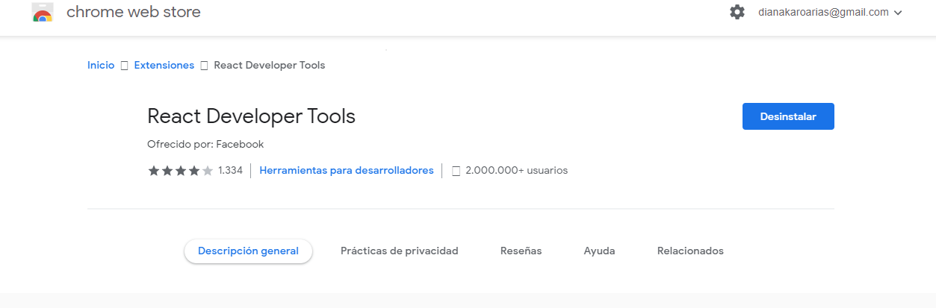Which allows us to know the time it takes to render certain segments of the code

To start with the activation profile, we will use the Admin panel that was carried out in react.

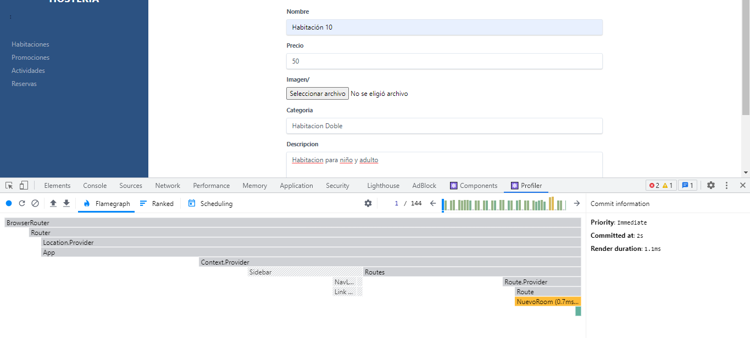

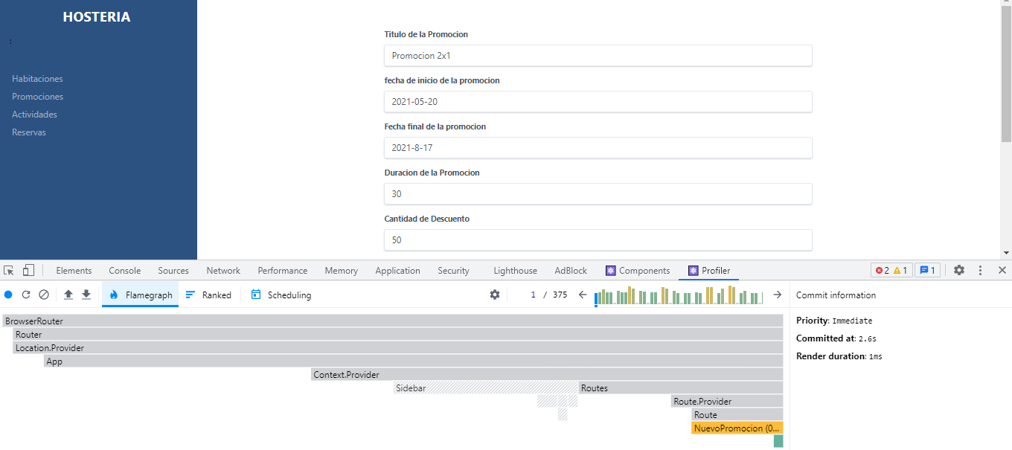As we can see, we have several components to review why problems are occurring, unlike Activities.

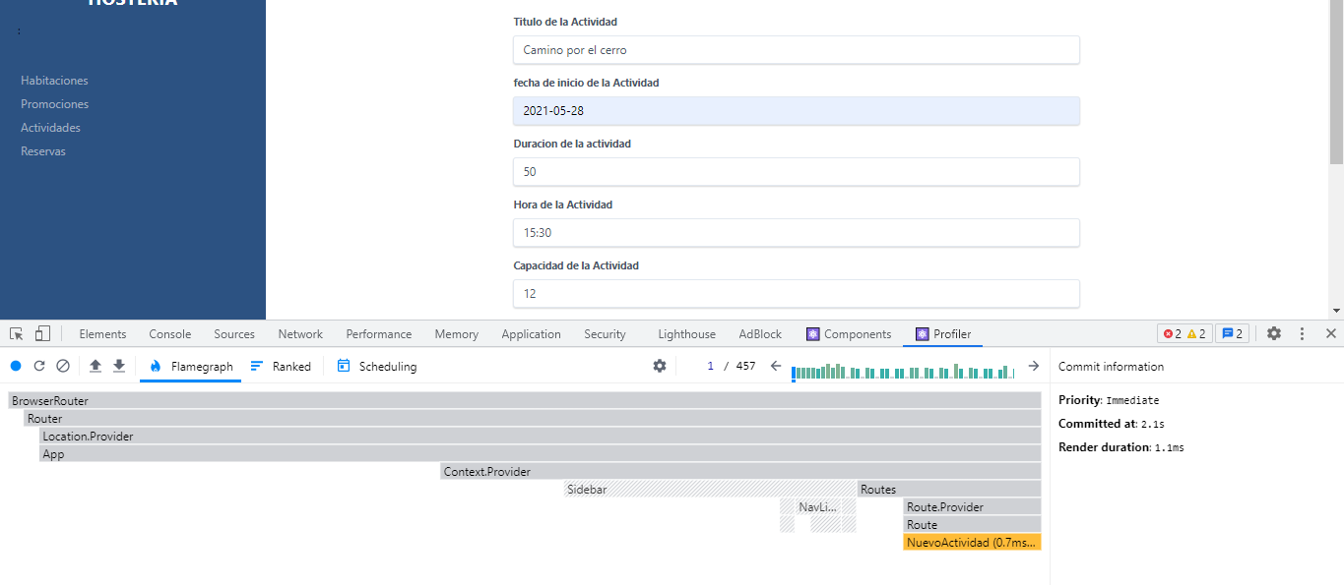Where we can see the guide that is given to us by means of the gray bars indicates that the time to render the information is small or, also described in another way, acceptable.

The same happens for the other sites that allow the creation of them.

App web: “Hostería Ríos y Montañas”

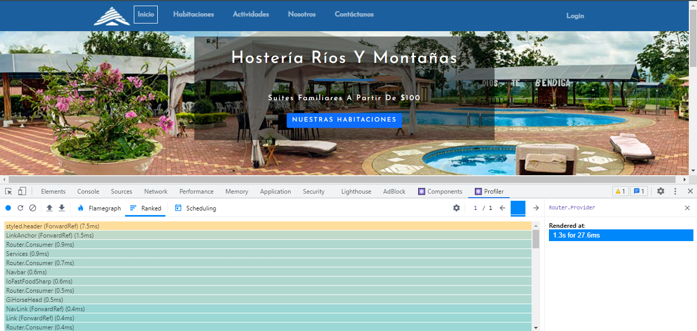How can we begin to analyze the response time when rendering part of the response code (In this case the first page) has an acceptable time. Like we could see the Admin panel.

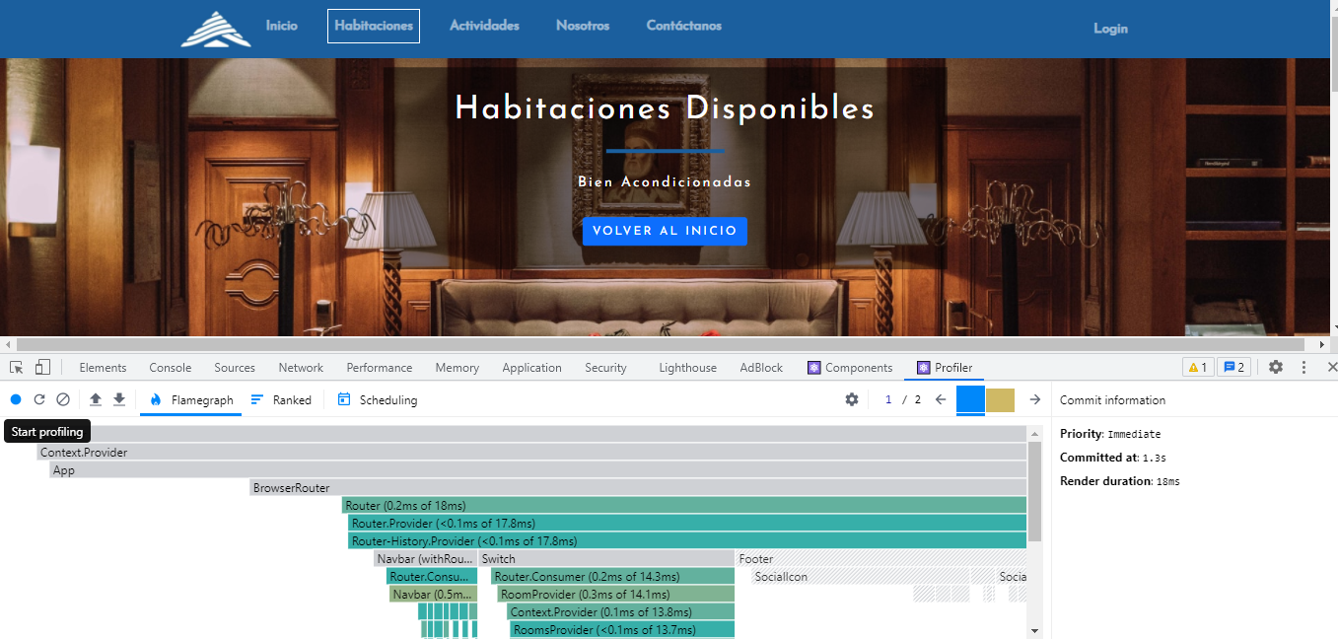the rest happens with the other tabs that will be displayed and which we can Access

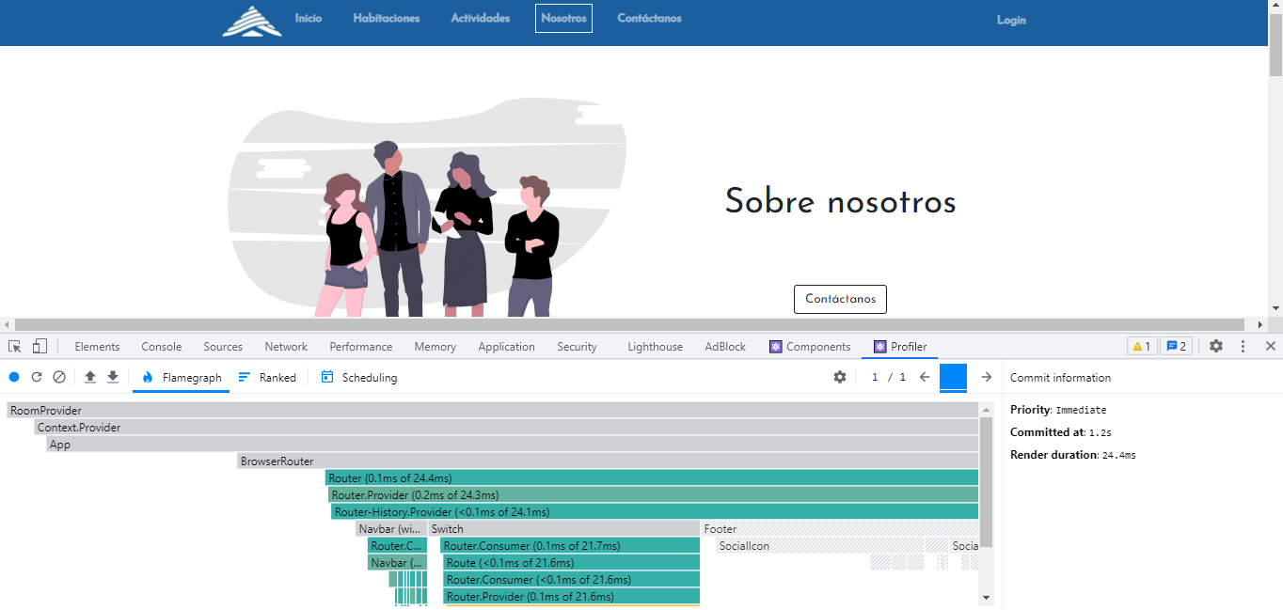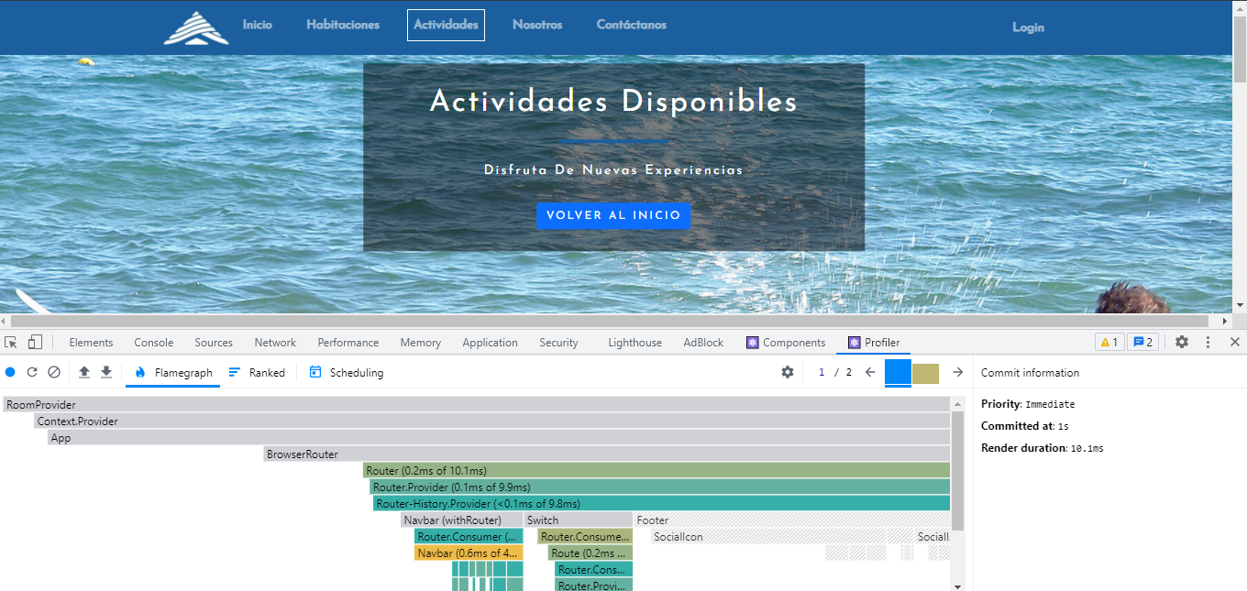

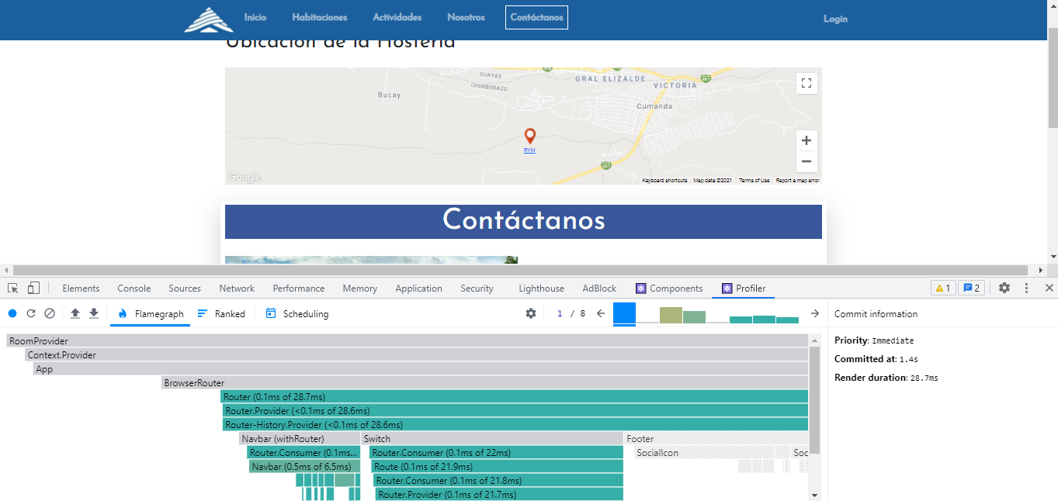As we can see, the gray bars indicate that this is not rendered and the green bars are that, these are rendered, but under an optimal time.

# Flow of windows and layout and system deployment guide

For the system Deployment Guide, we made two guides and also 2 videos to provide a evidence and how the apps works.

**System Deployment Guide Video App Movil**: <https://youtu.be/5j7SaZQ47n0>

**System Deployment Guide Video App web:** <https://youtu.be/Mvd3xrwjvHk>

## 7.1- Flow windows Guide App Movil

Look in the archive of the project, there is a .pdf

## 7.2- Flow windows Guide App Web

Look in the archive of the project, there is a .pdf

# Use of a single sign-on service with an authorization framework.

Provides an authentication solution, through flows managed by a user access UI. It has an Auth component implemented which is used for websites and mobile devices that can maximize access conversion. Through this authentication you have a better security since you can get relevant data that are accessible with verified emails.

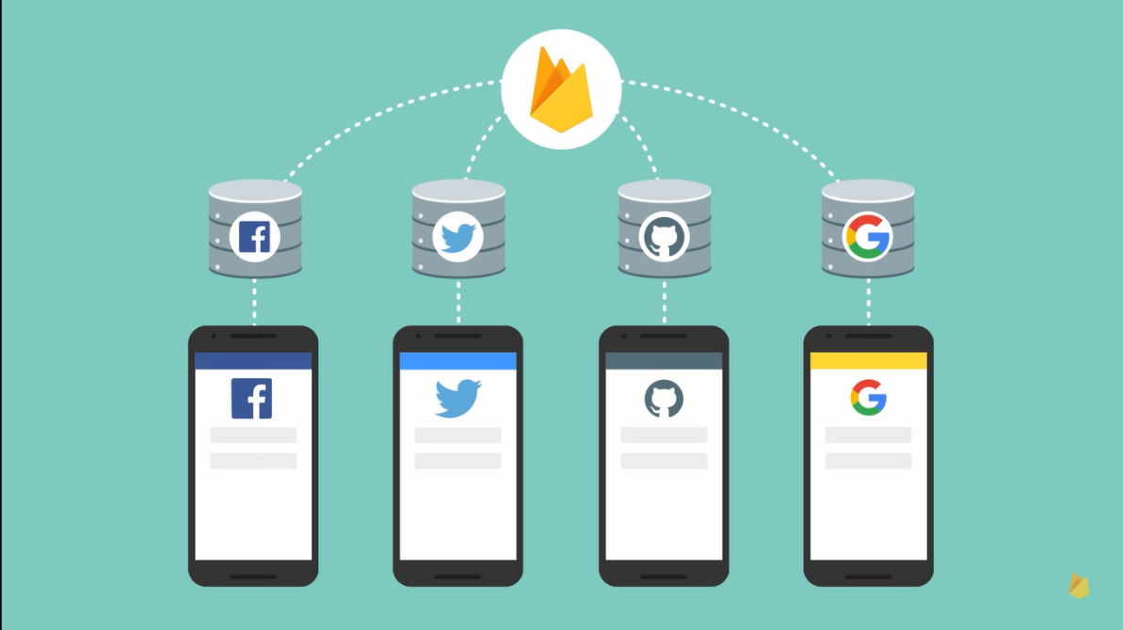

It has a comprehensive security through Google, Smart lock and by the password manager in Chrome.

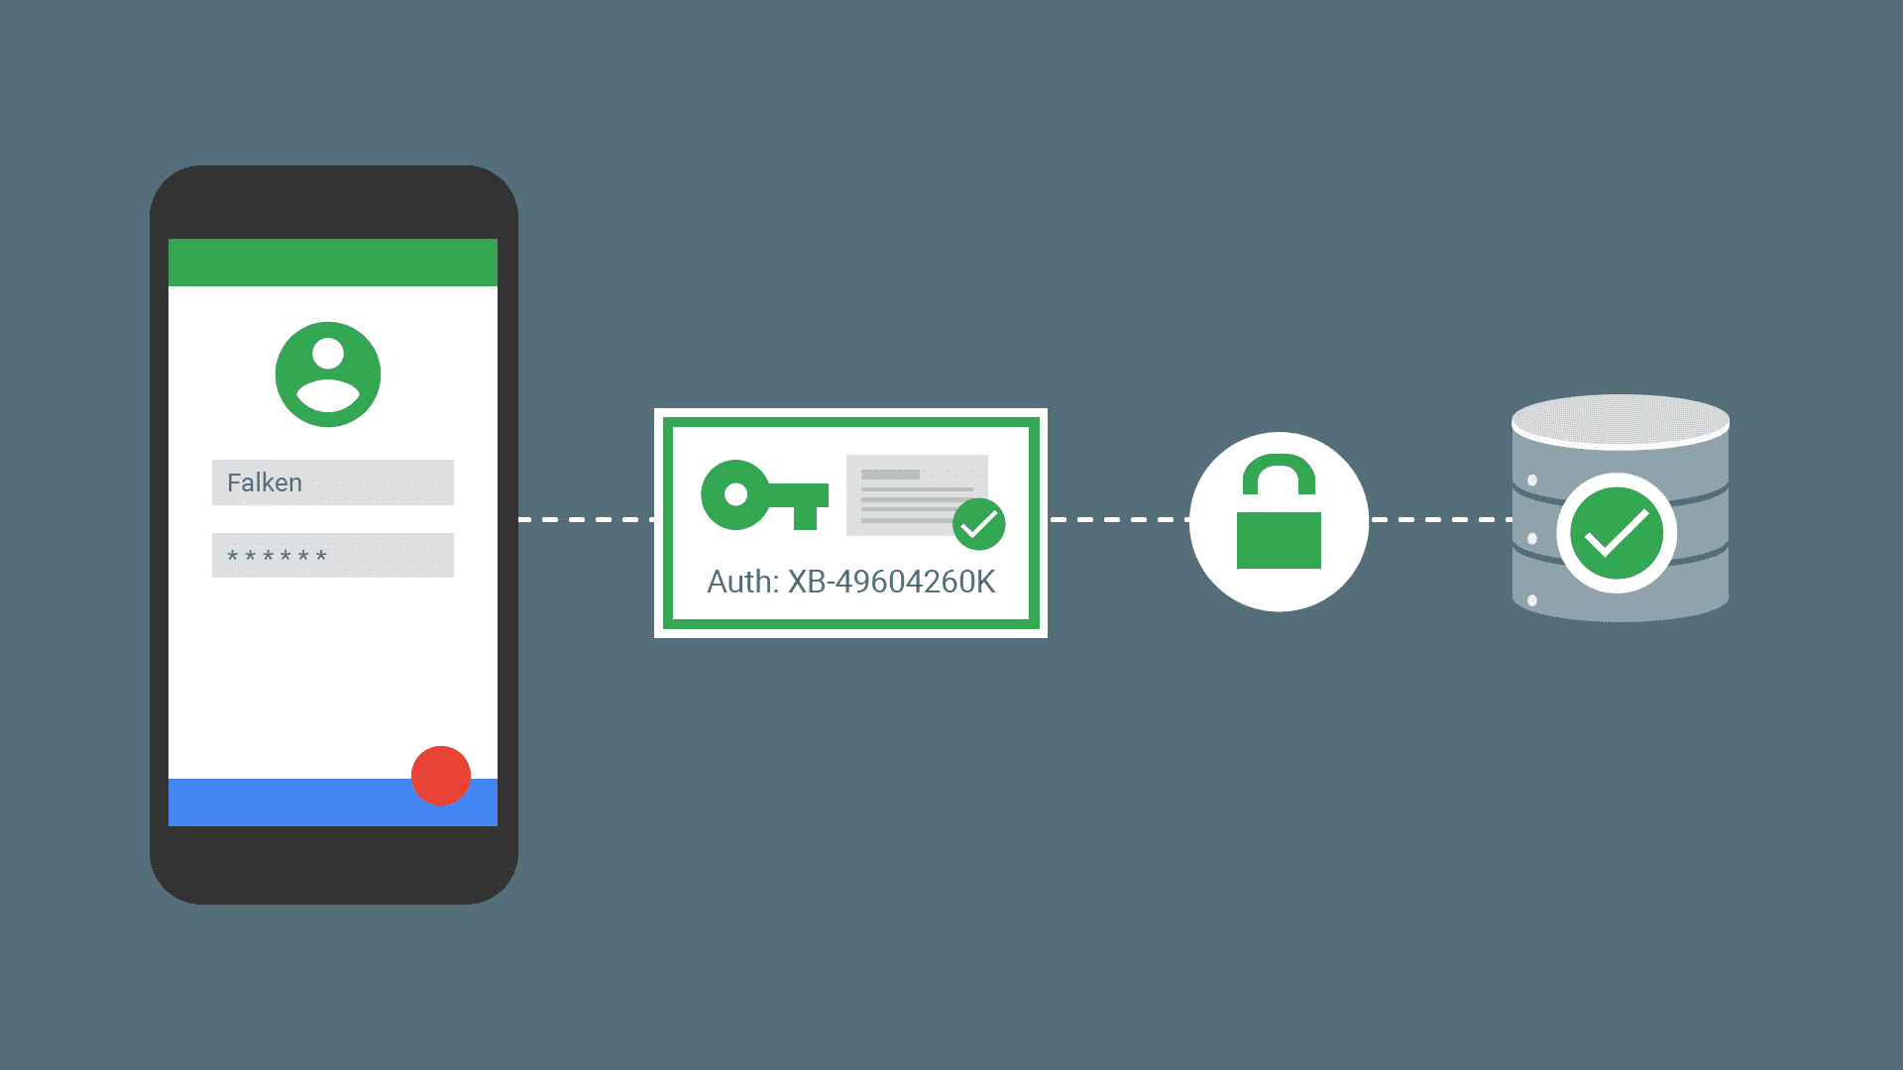

Our code validates the emails, if they exist it returns a token with that information.

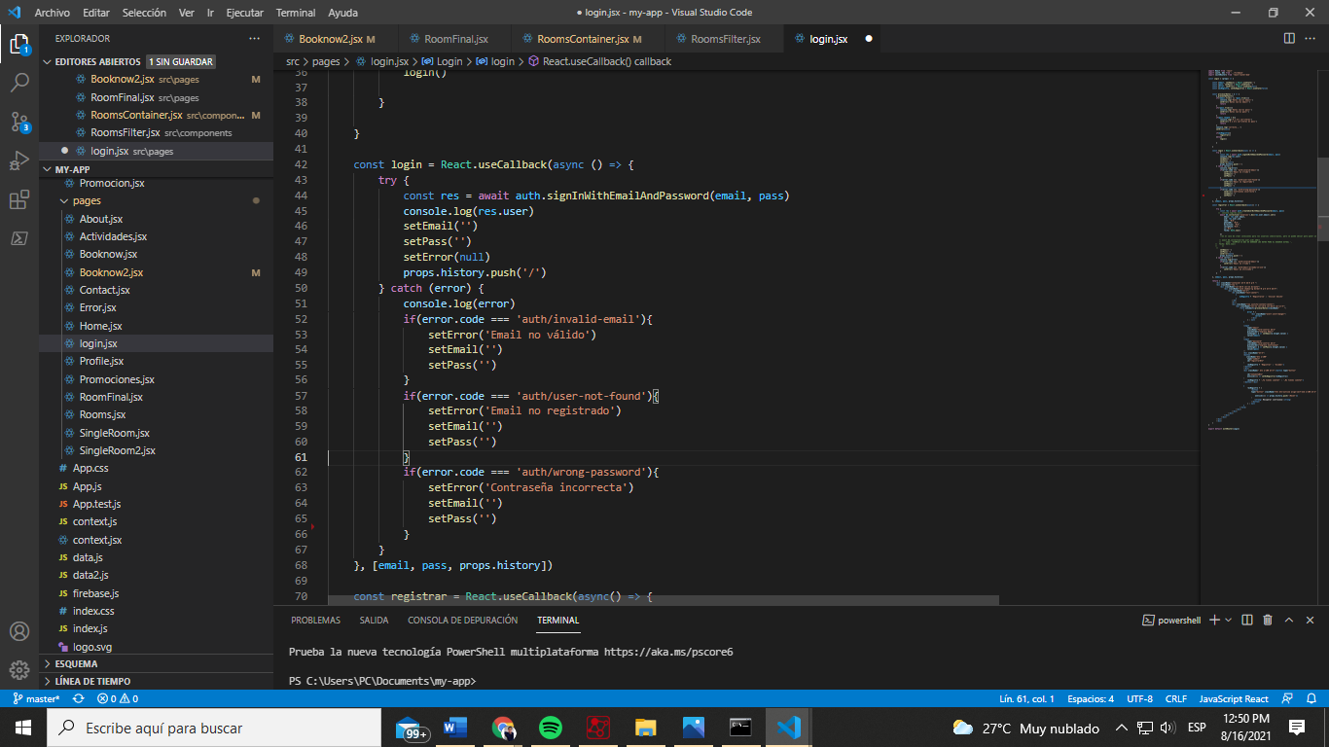

Through this function we can validate registered users in our application and thanks to the comprehensive security you can reset the password by means of"firebase"where a link is sent to the end user's email and if you wish you can proceed to make the change.

# Video showing the sprint review process.

* Link of the video:
* If the link before does not work you can also download in the git repository:

# Software system deployed into a production environment.

Production environment for the App web was in the hosting of firebase and goDaddy.

* **Link of the app web deployed in firebase:** <https://hosteria-95a60.web.app/>
* **Link of the app web deployed in goDaddy**: <https://rymhosteria.ing-soft2021.com/>
* **App Movil apk:** Look in the GitHub repository there is a .apk

14- Extra-Use of a GUI test automation tool

It has been used "google developers", is a tool created for developers with many functions, with which we have tested some windows of our page.

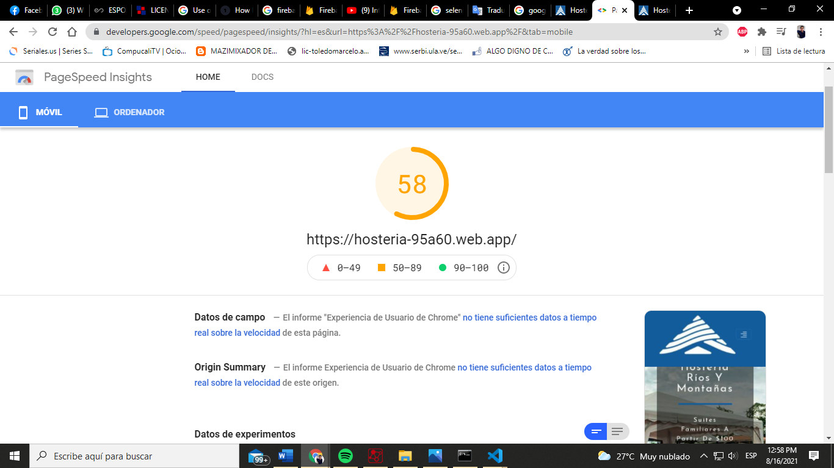

For the mobile and web part the load test has medium speed in load time from a mobile application, in the web part a certain similarity was shown in the load test.

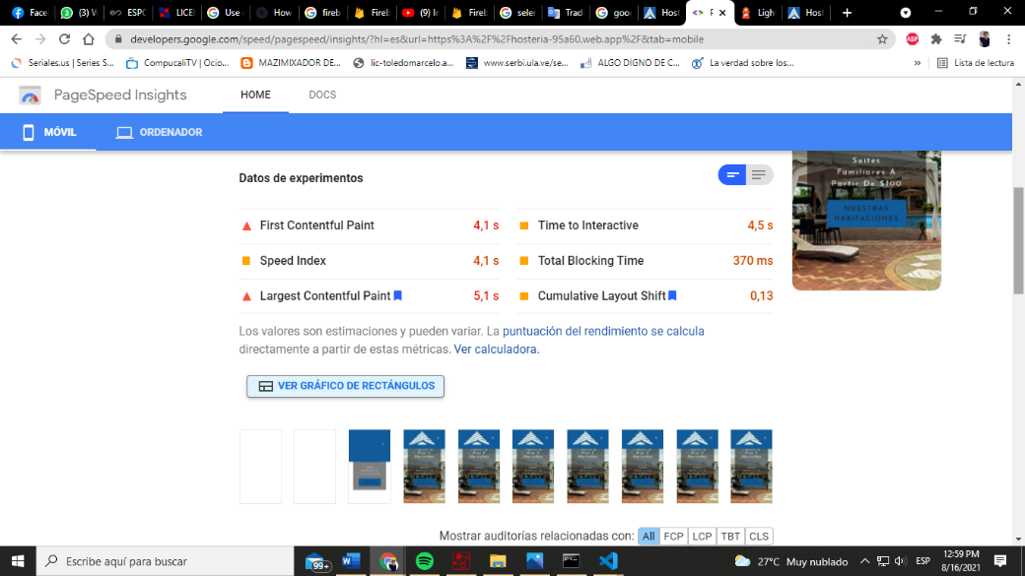

The app gives us a lot of data, such as data from experiments and some recommendations for diagnosis by web and mobile.

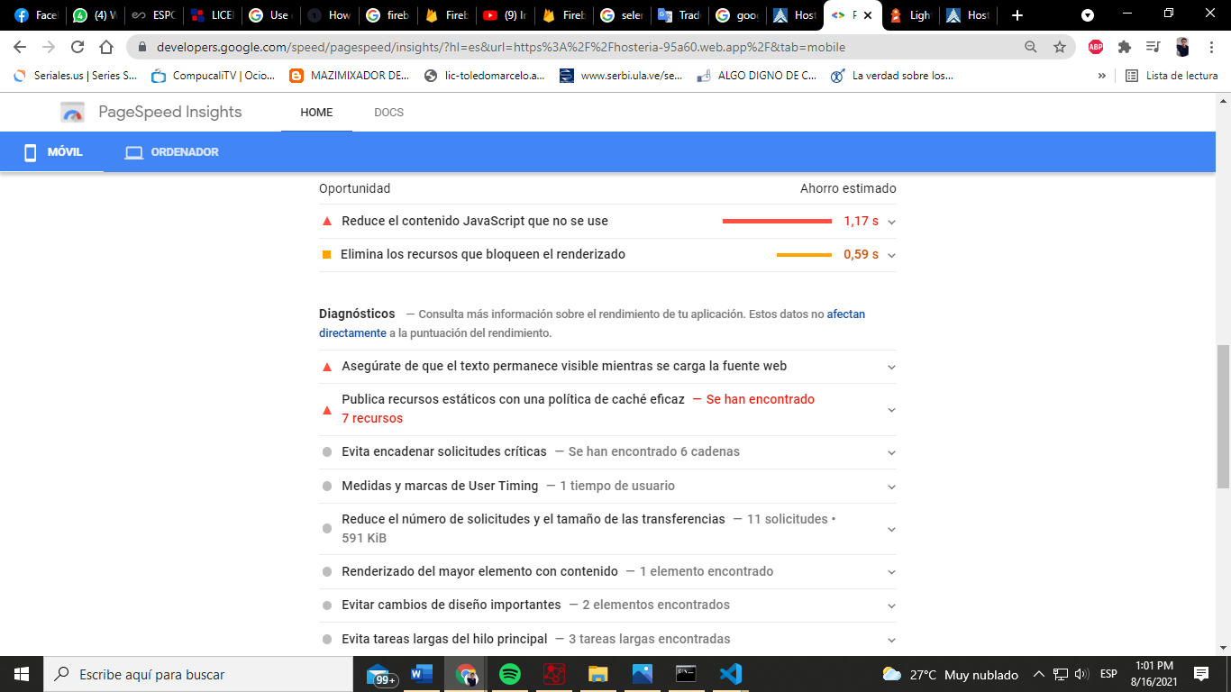

After applying the appropriate modifications to the code, the app improves its loading performance.

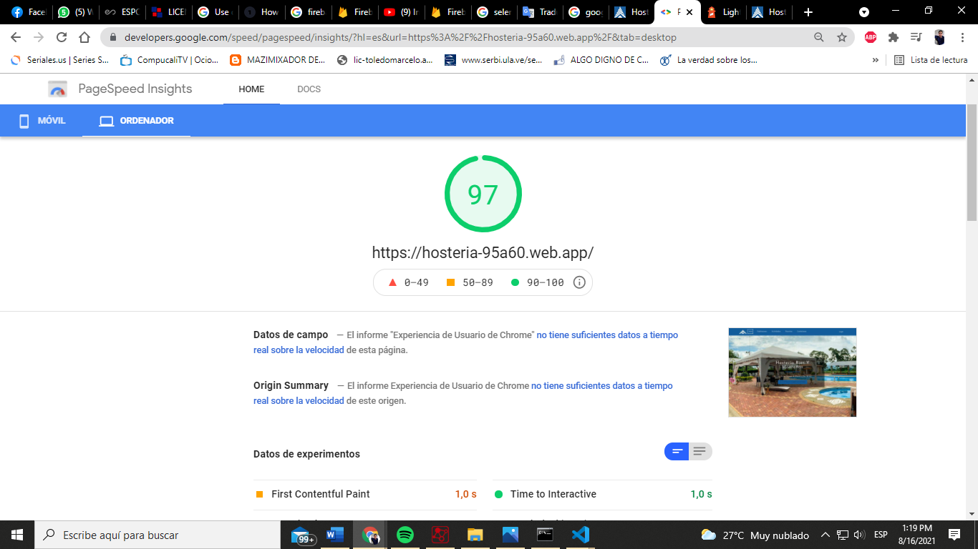

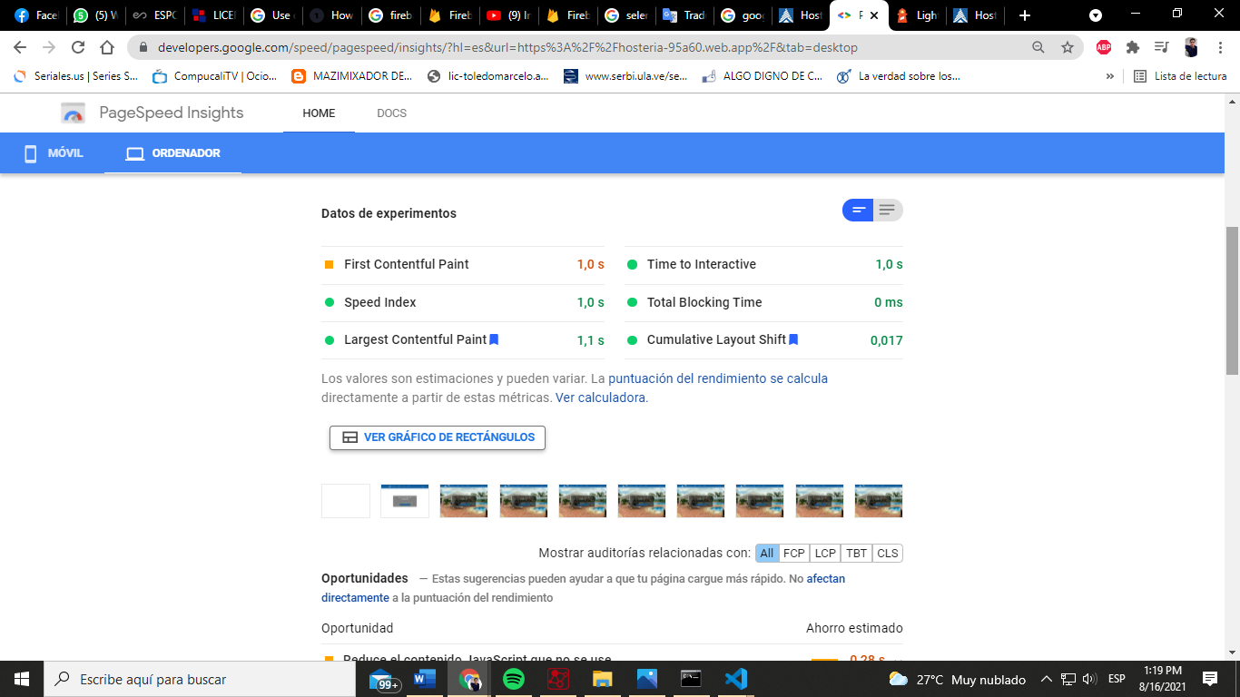

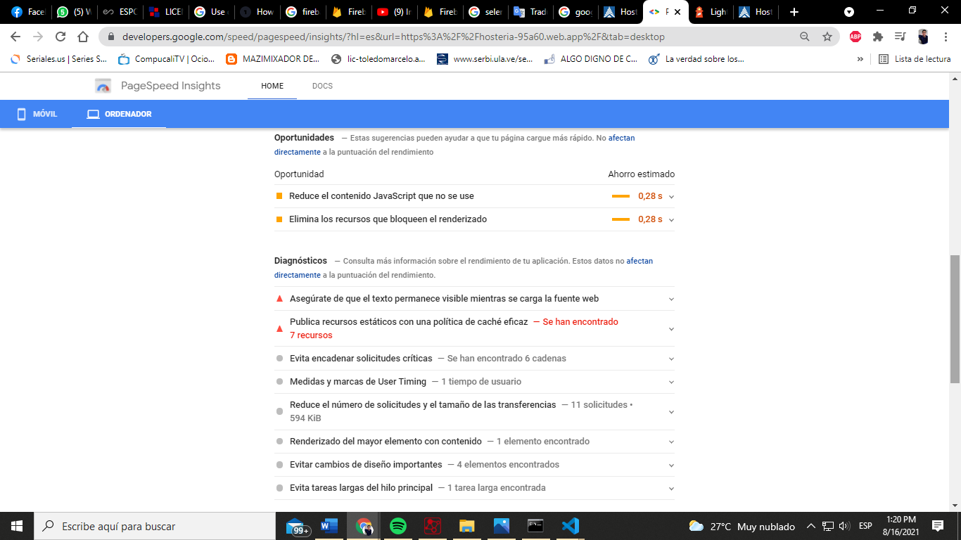

Source :<https://developers.google.com/speed/pagespeed/insights/?hl=es>

1. Extra-Load Testing

With the same "Google developers"but now we use "Lighthouse" with all its features. To access this Google feature or tool we must place ourselves on the website you want to analyze, then press inspect and in the bar on the right side where it says: elements, console, source and others. Search lighthouse, select the categories to analyze and the type of device. To finish just click on generate report and wait.

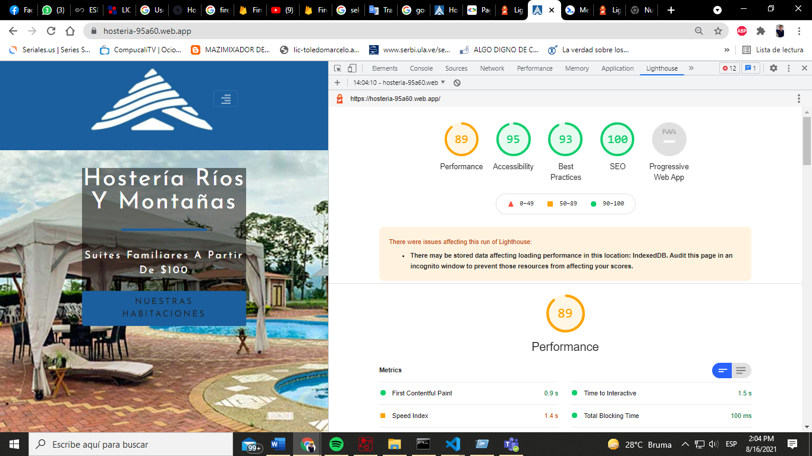

With improved code, we can see how performance is in range. To be extremely optimal, you should reach more than 90 in each section.

**Performance** is the interaction time to determine the load delay, in other words, the load time.

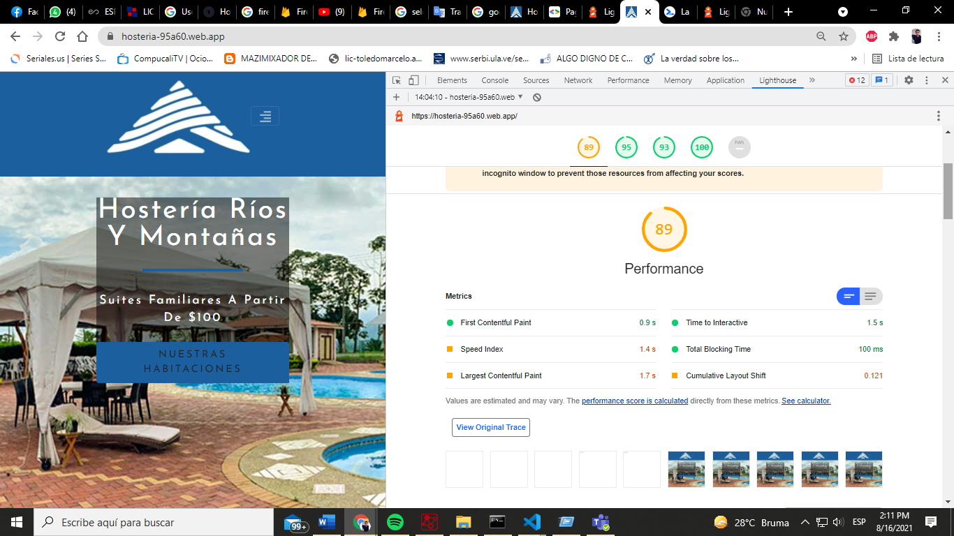

In **best practices,**rate the use of HTTPS within the entire render of the page.

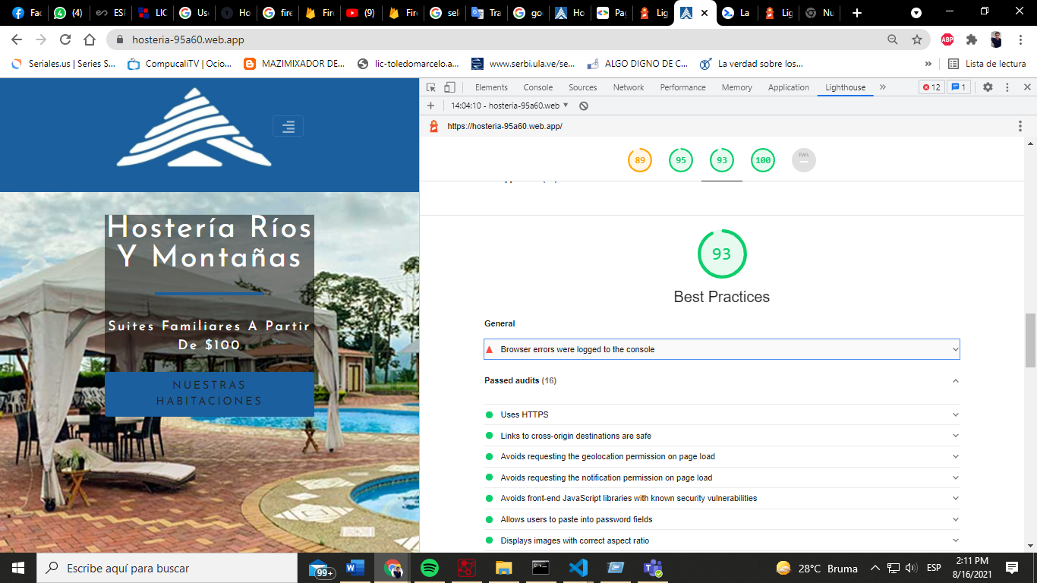

In **SEO** verifies the quality of the code or implementation for a better positioning on the web.

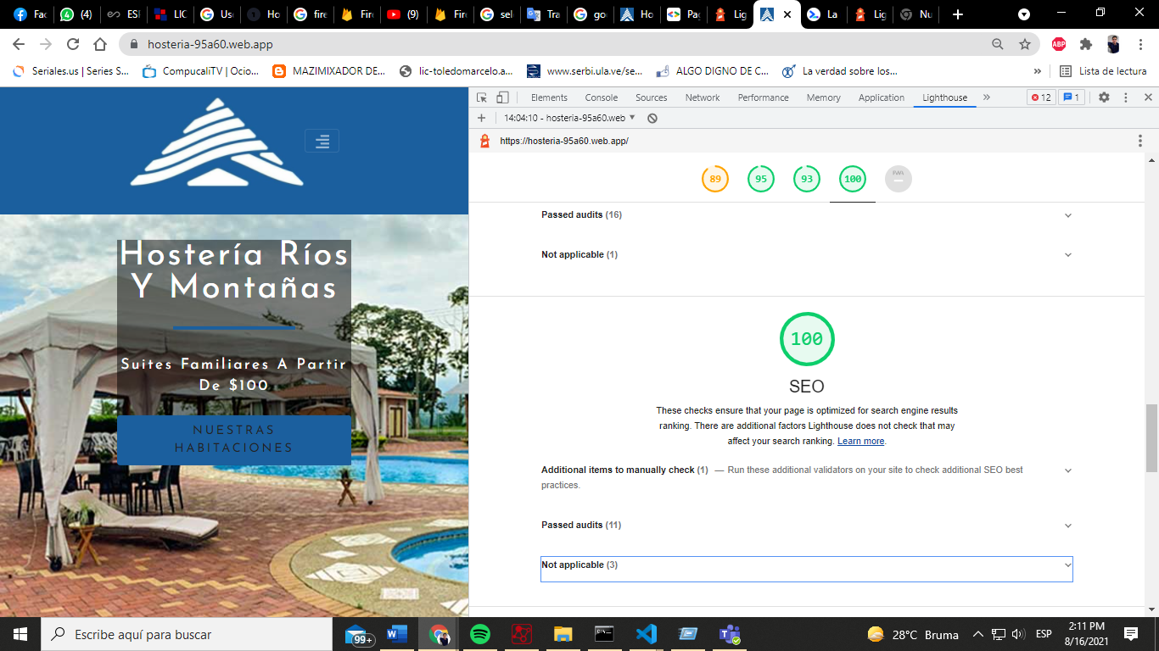

**Accessibility** checks for common issues that might prevent multiple users from accessing content.

